*Google Map – Tab 1 (Backend)*

**Setting up Google Maps**

Prerequisite: Created a Firebase Project

Open a web browser of your choice ex. Google Chrome.

Search for Google Cloud Platform || Click on this link: <https://cloud.google.com/>

On the top right of the page, click on “Sign in” and login with your Gmail Account.

Click on “Console”

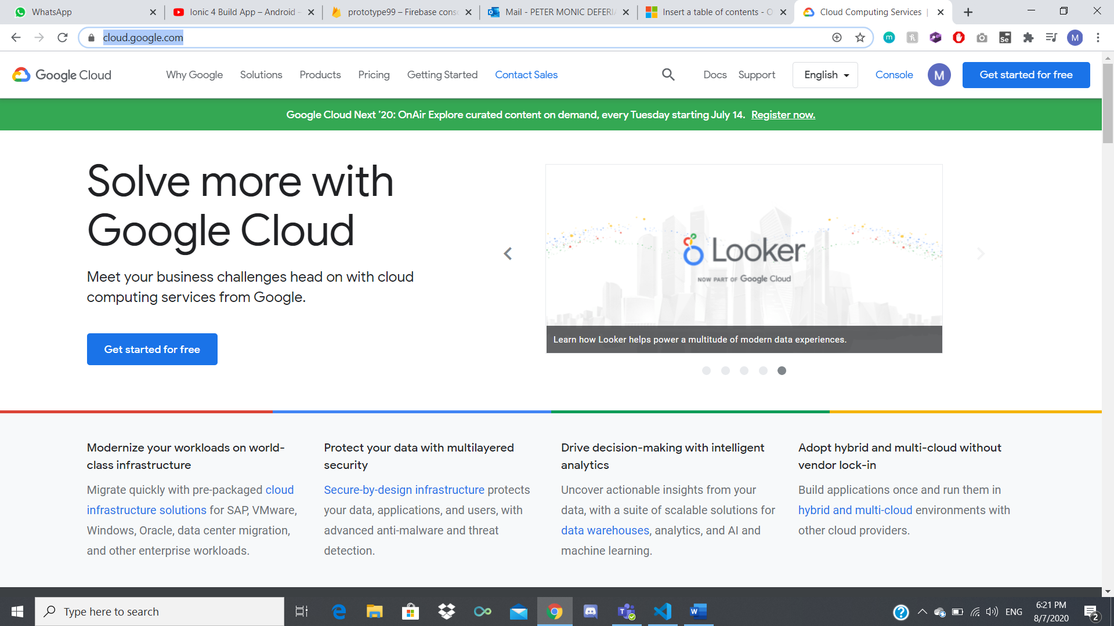

On the top left of the page, select your Firebase Project and open it.

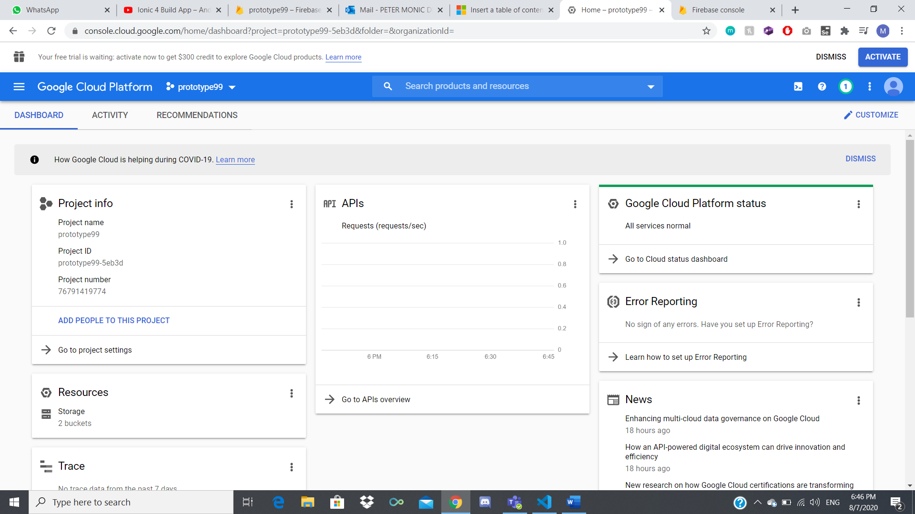

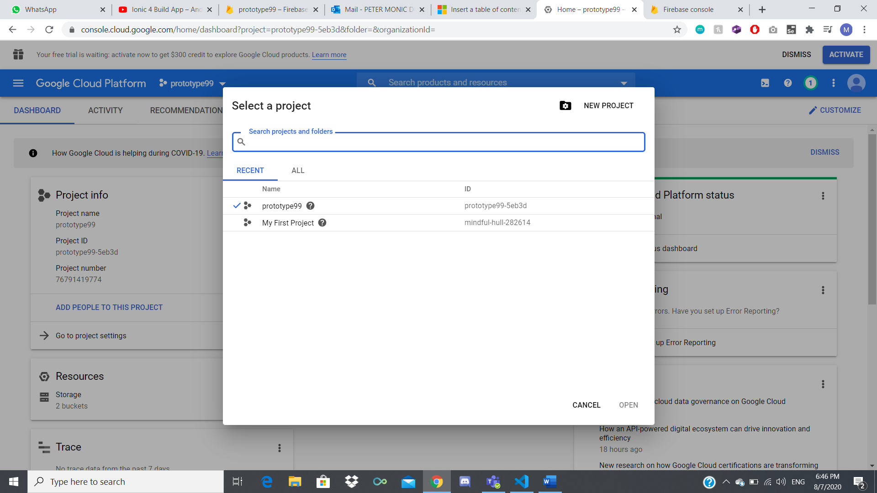

Click on the Navigation Menu > APIs & Services > Library

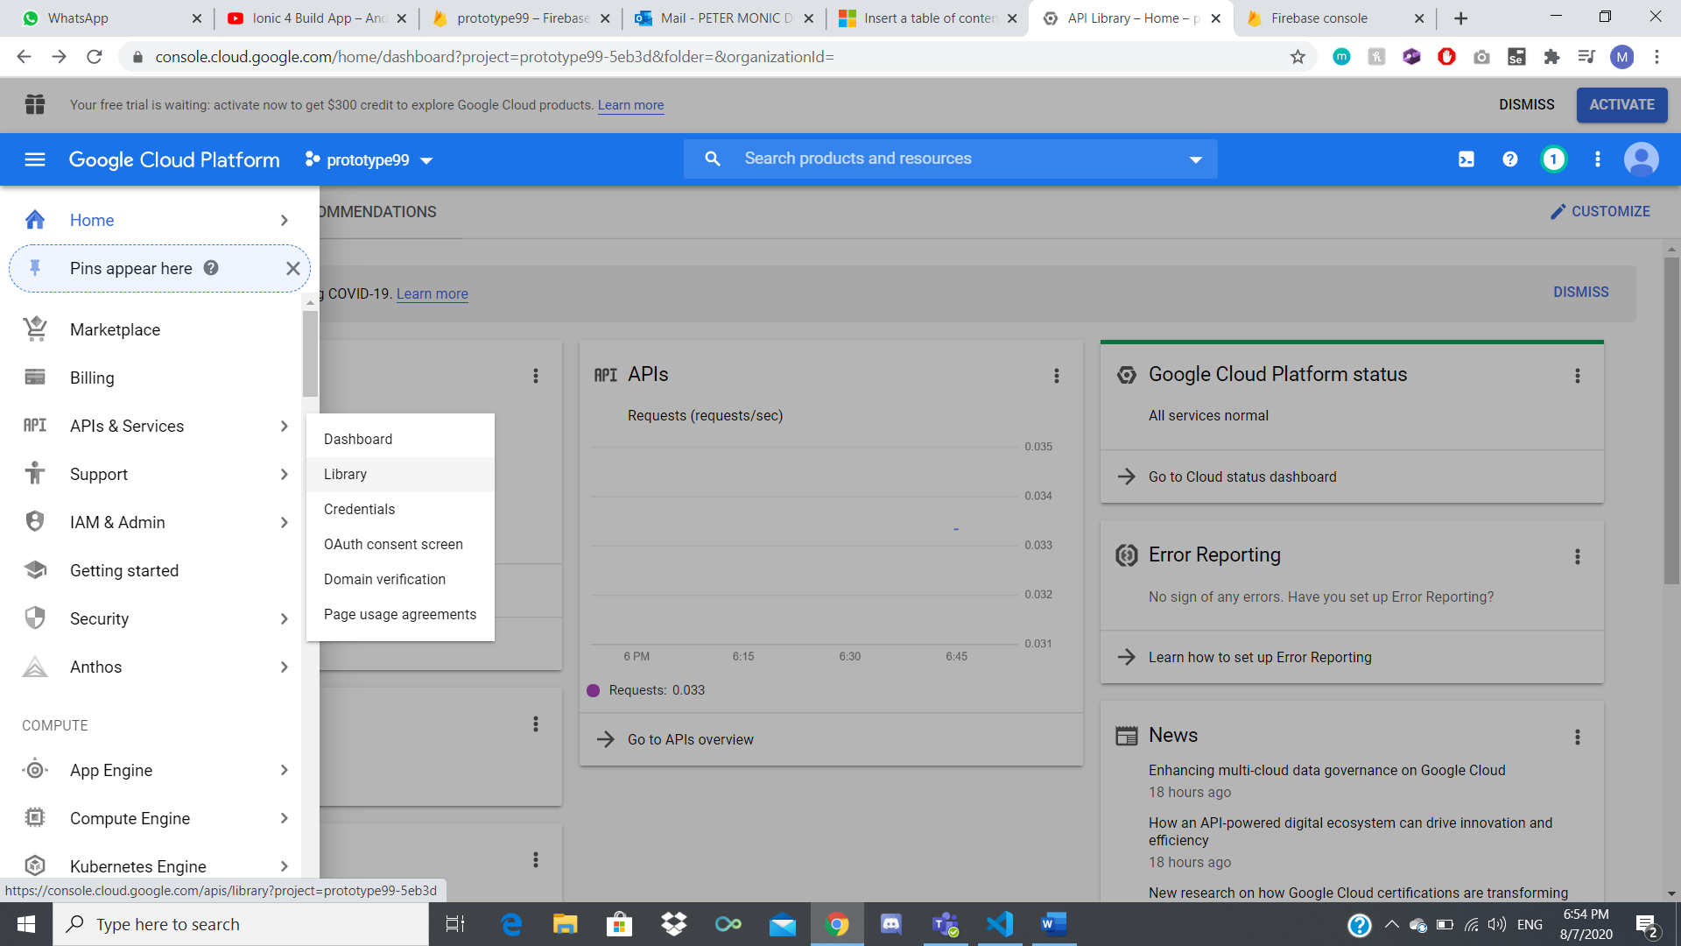

Click on “Maps SDK for Android” (Do the same for “Maps JavaScript API”)

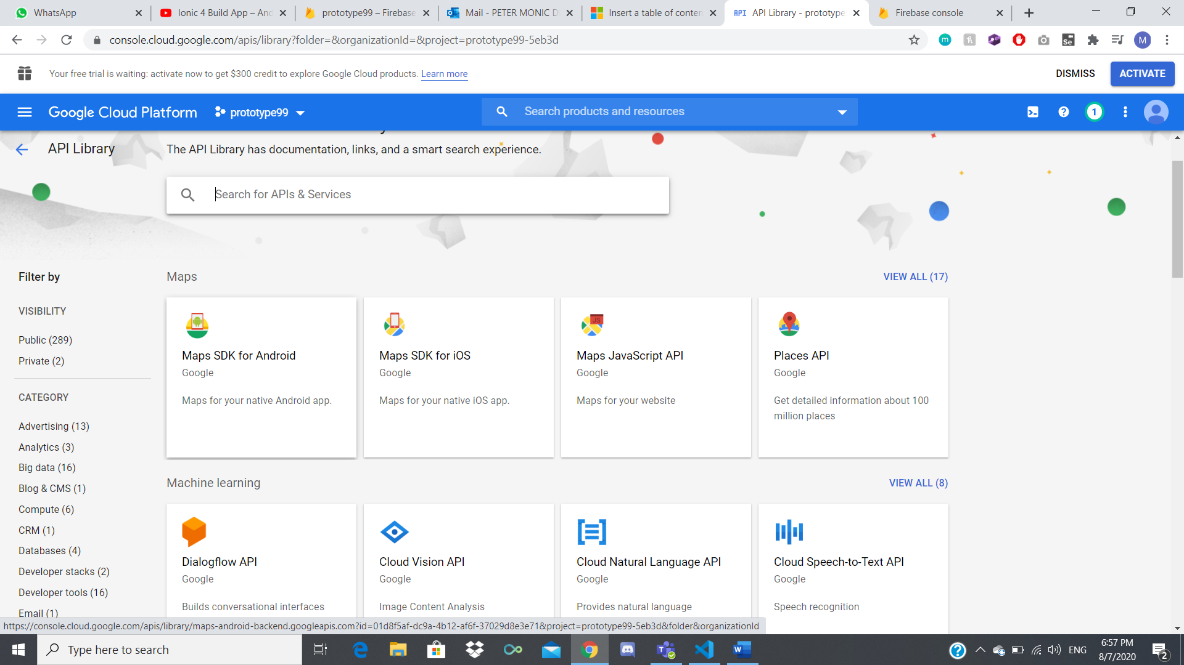

Enable both APIs (Should look like this)

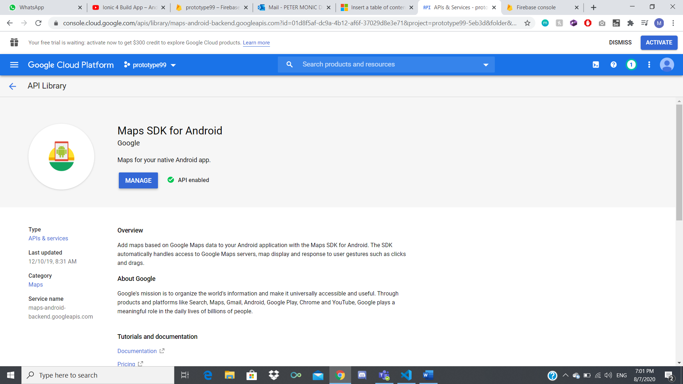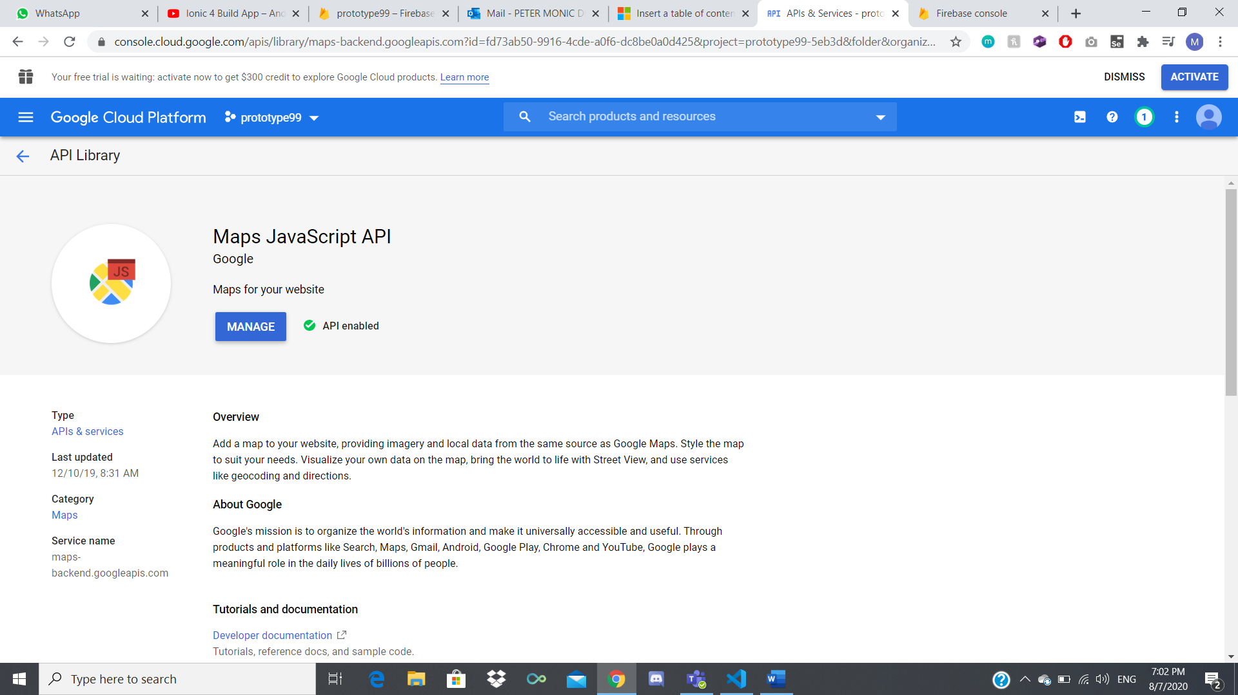

Click on the Navigation Menu > APIs & Services > Credentials

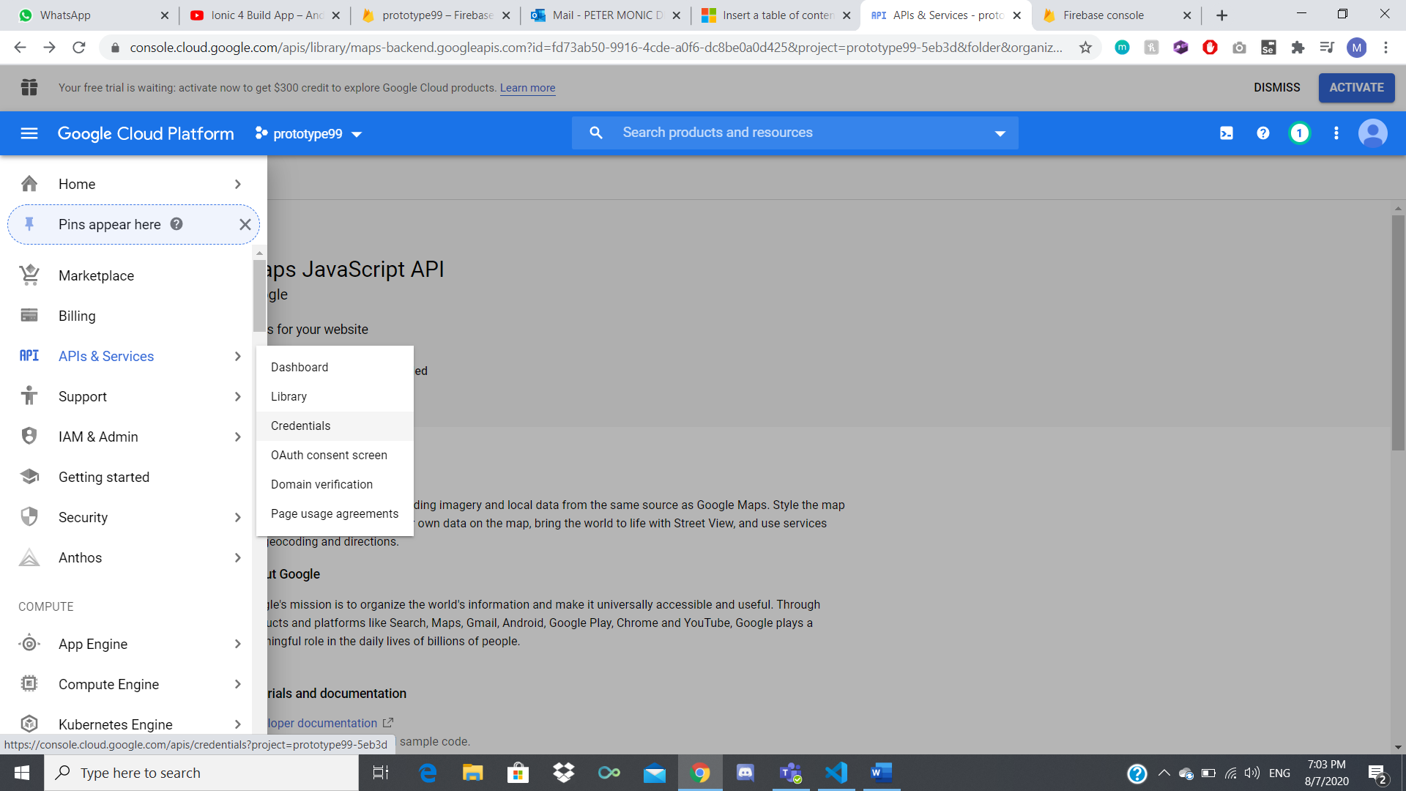

On top of the loaded page, click on “Create Credentials” > API key

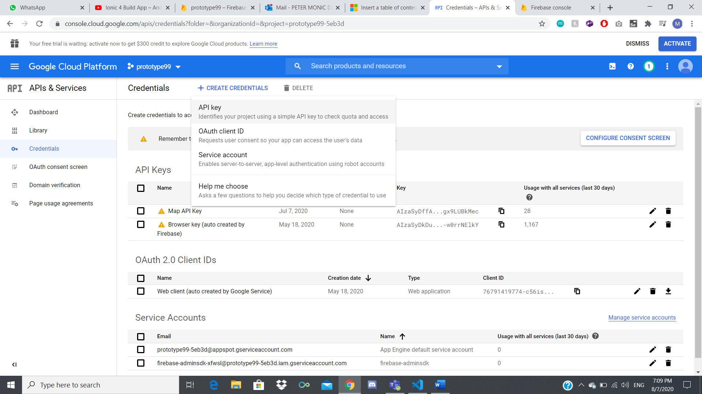

Copy the API key and open the “MPApp” project folder in Visual Studio Code.

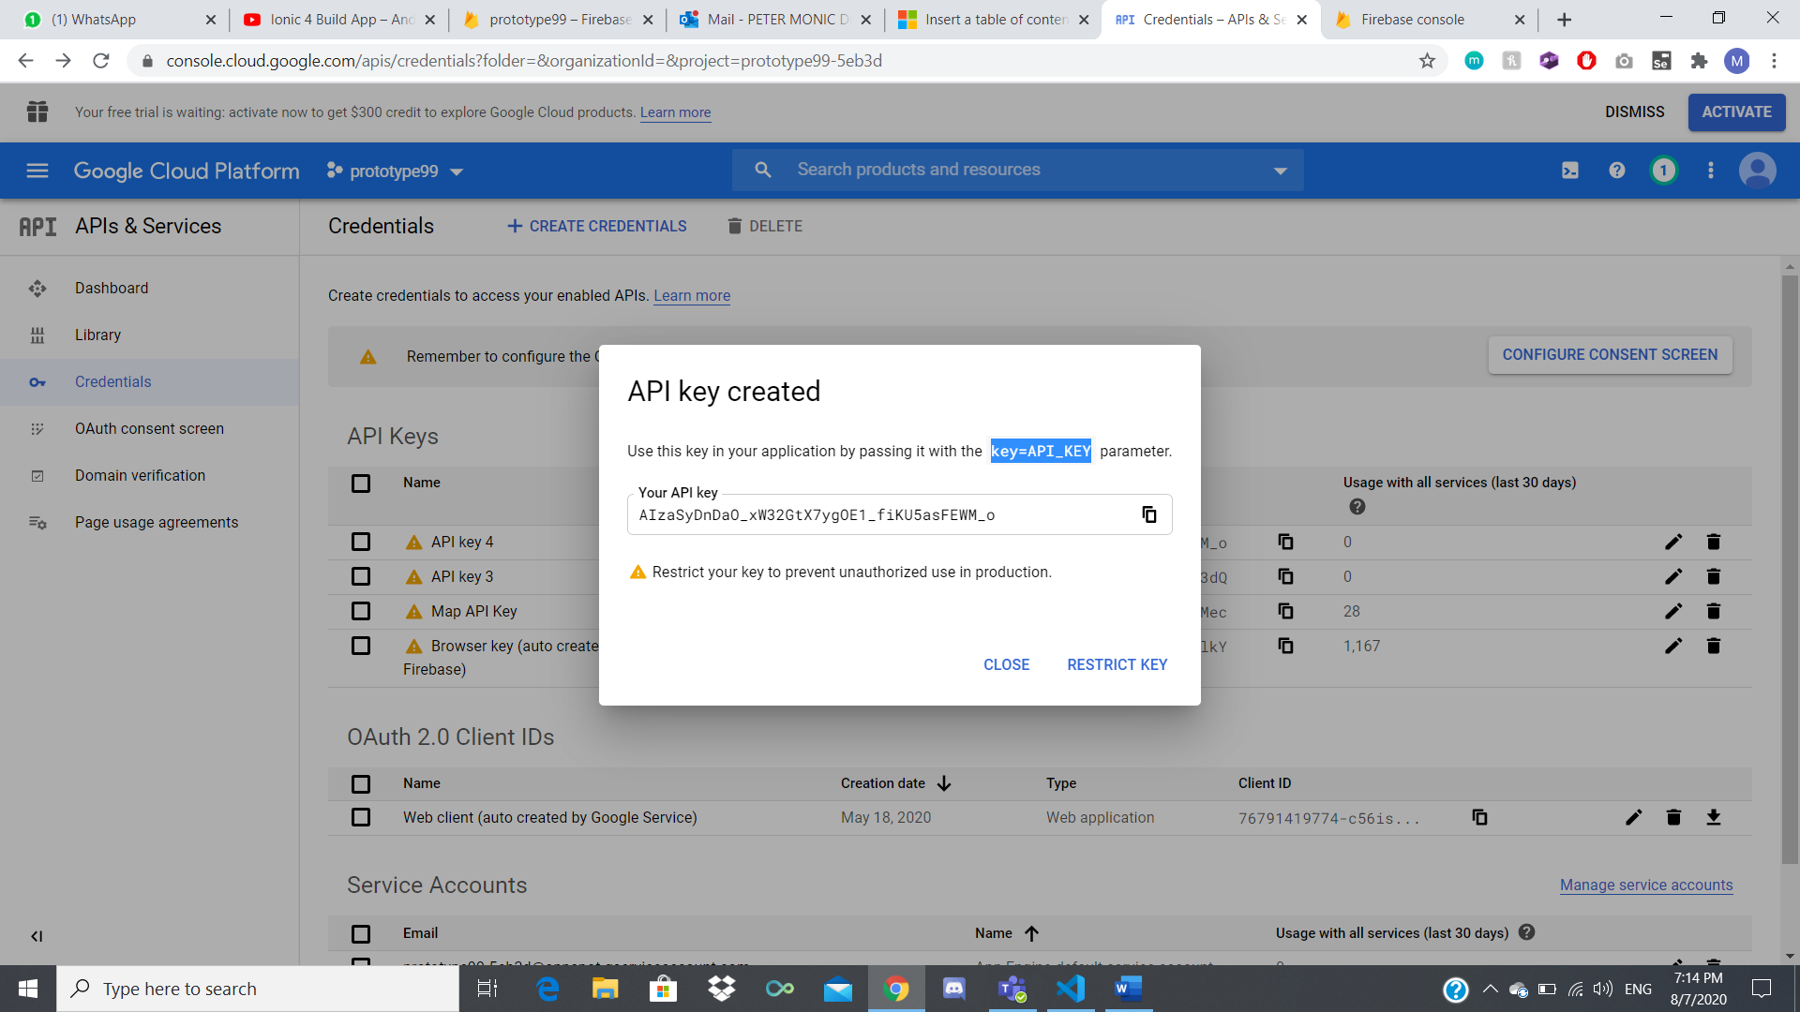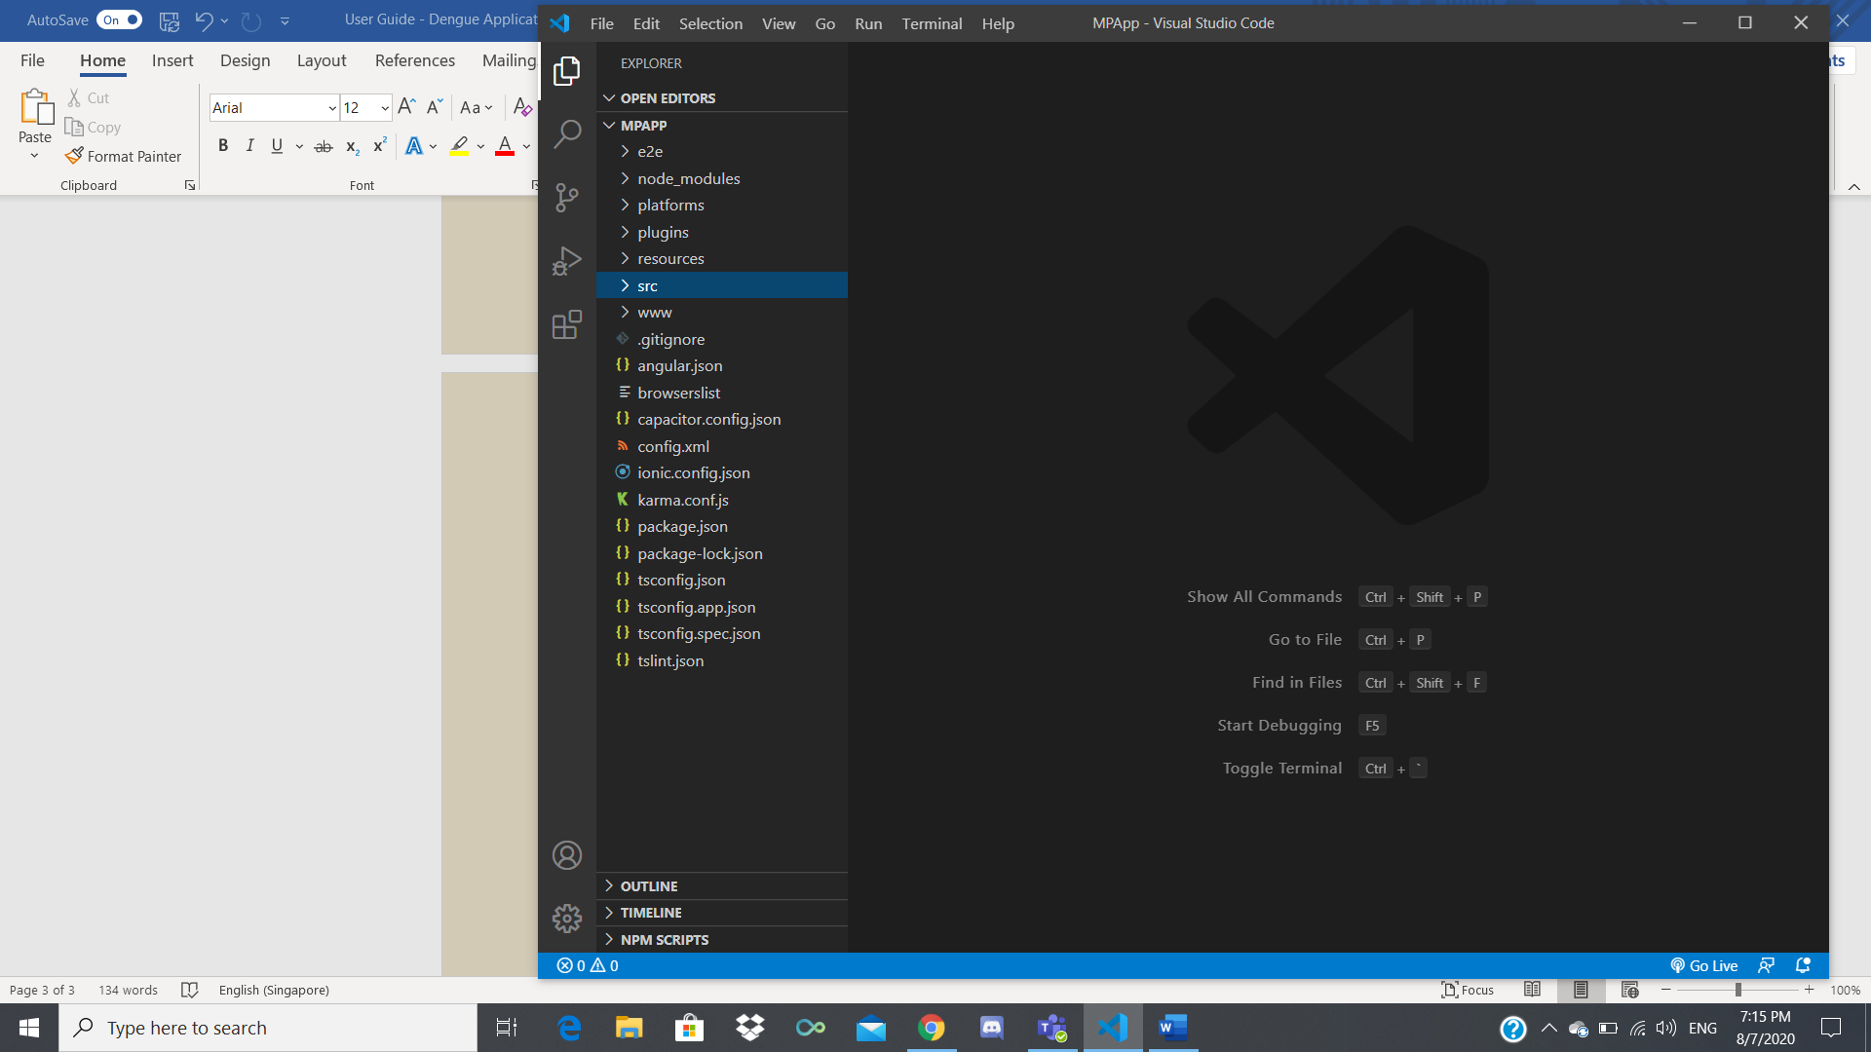

Locate index.html file (src > index.html) and change/paste the API key in the script

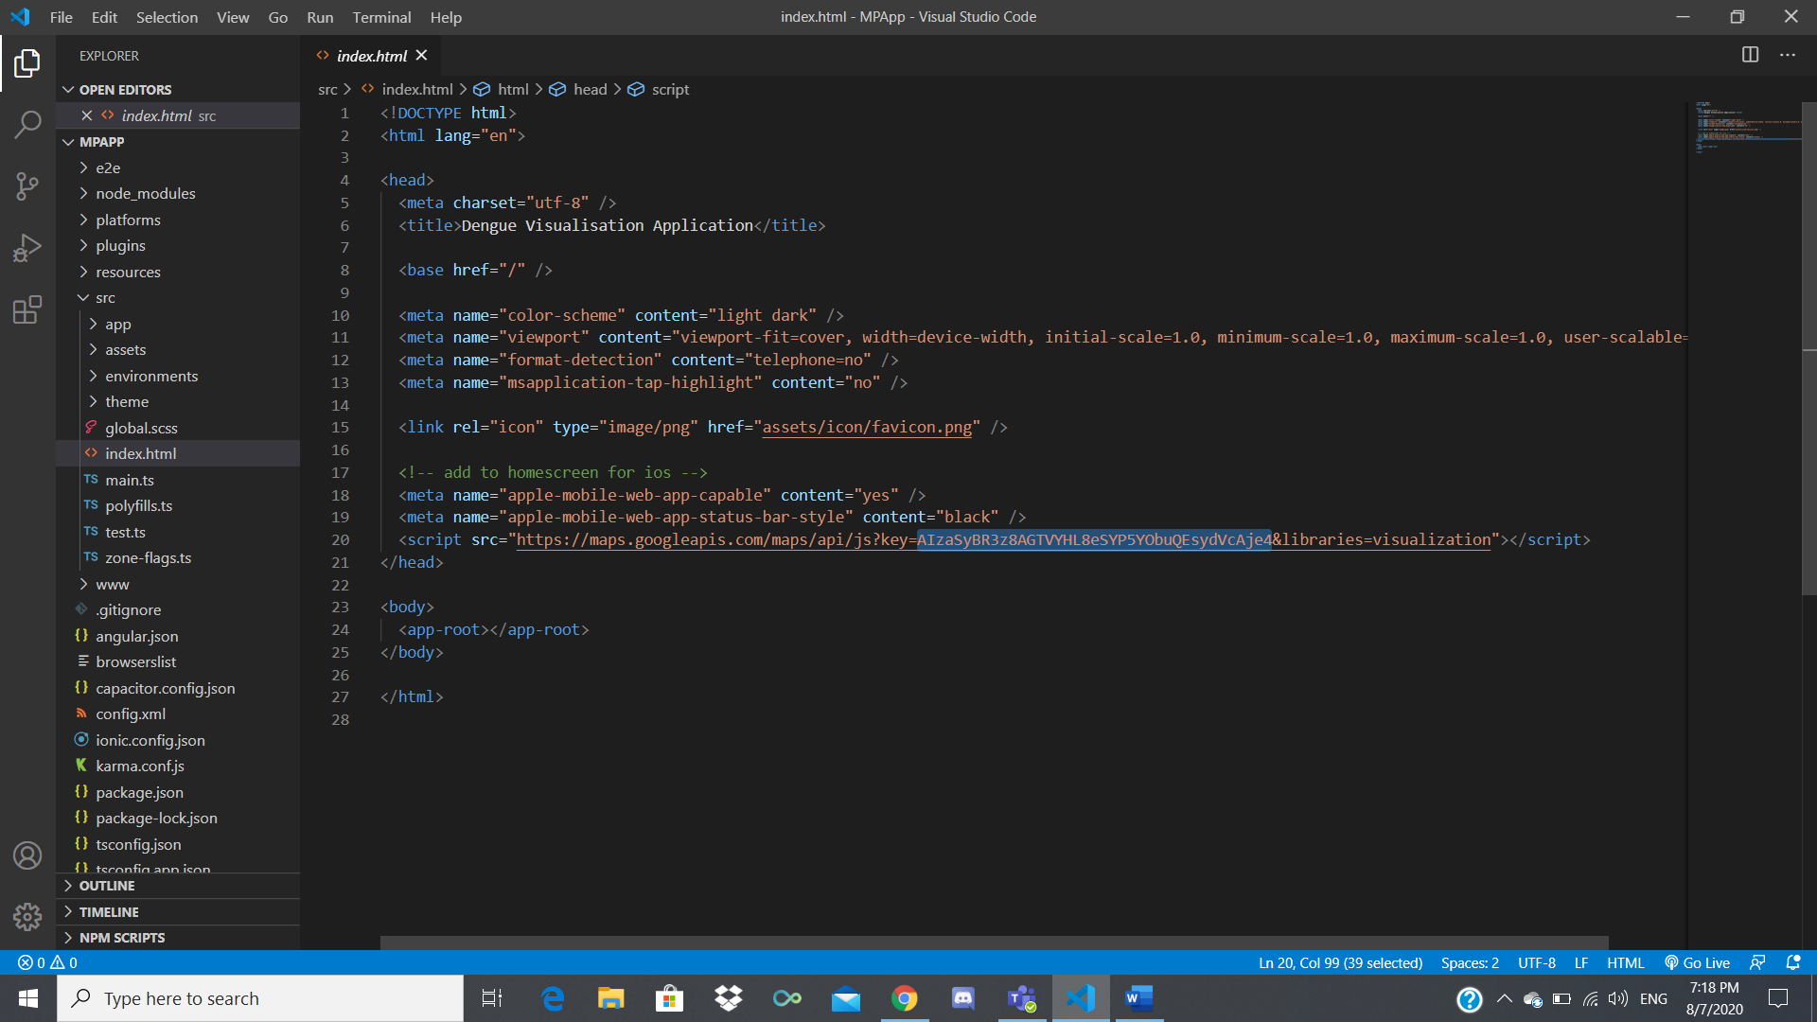

Save it.

Google Maps will only work if you have “Billing” enabled and set in Google Cloud.

Click on the Navigation Menu > Billing

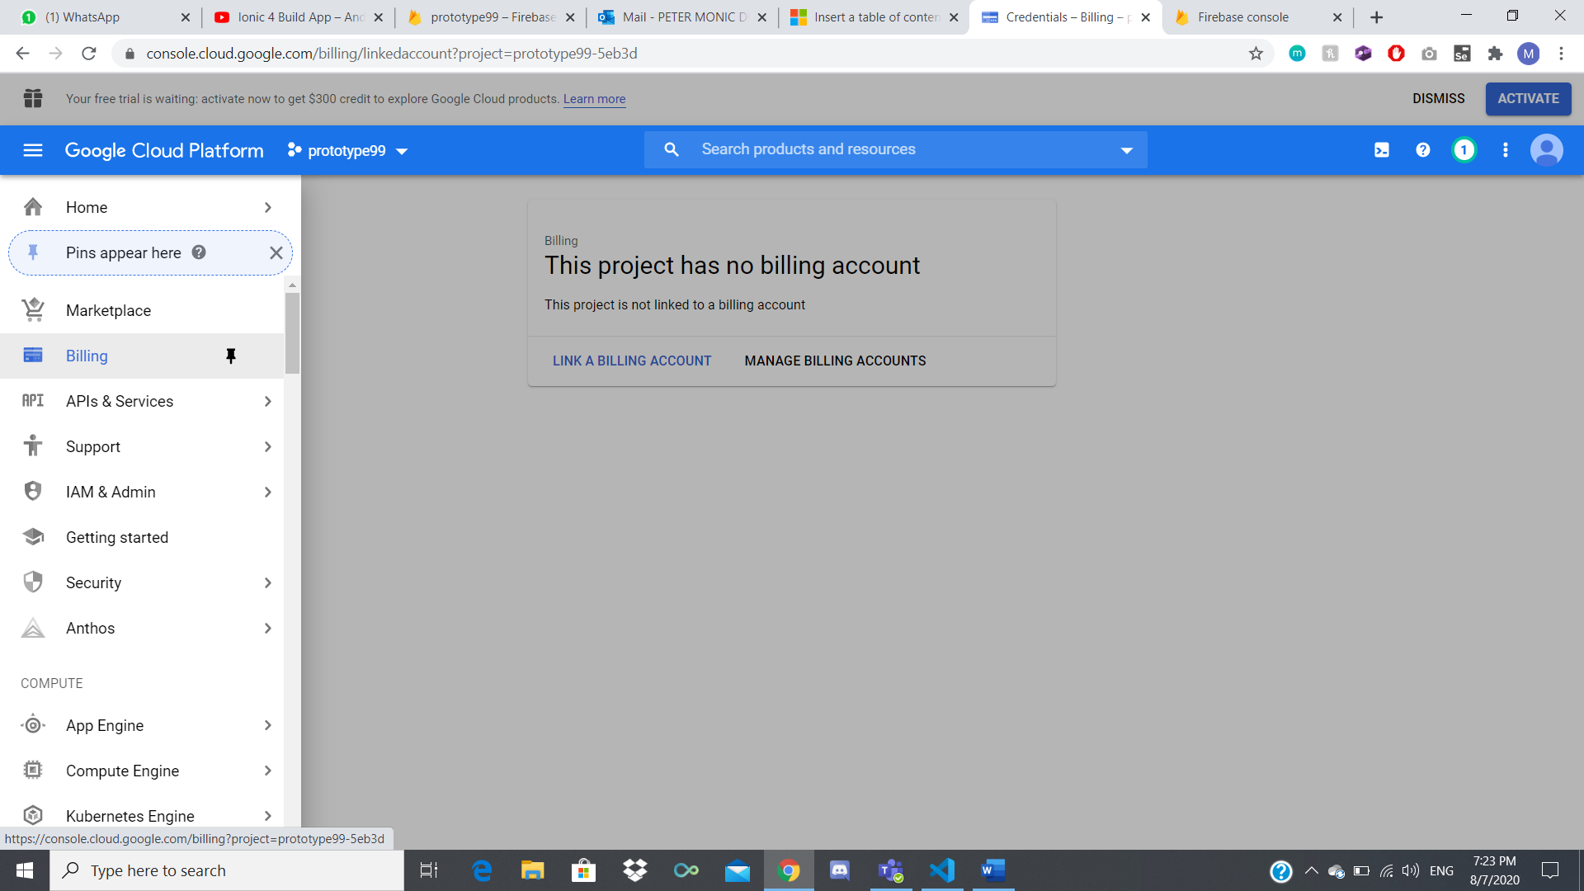

Click on “LINK A BILLING ACCOUNT” > “CREATE BILLING ACCOUNT” and fill up the details.

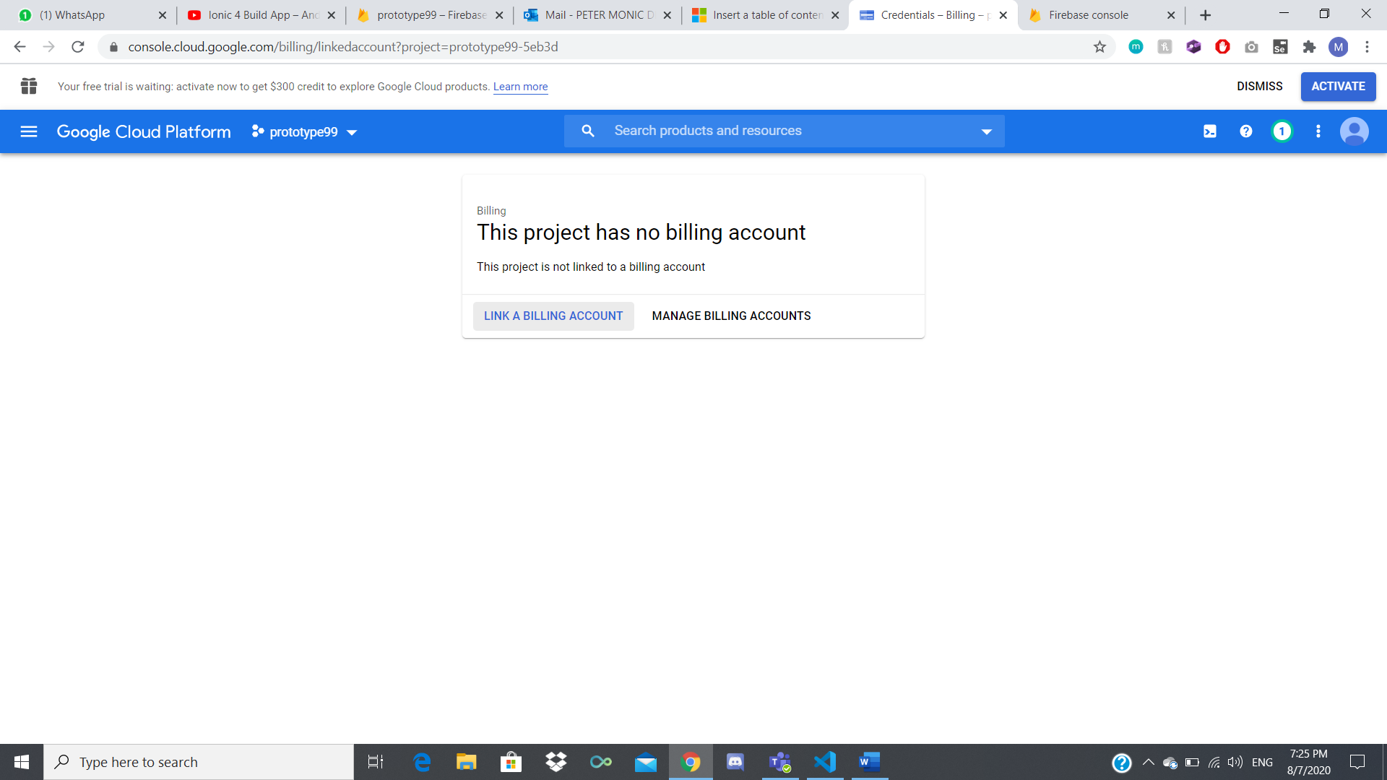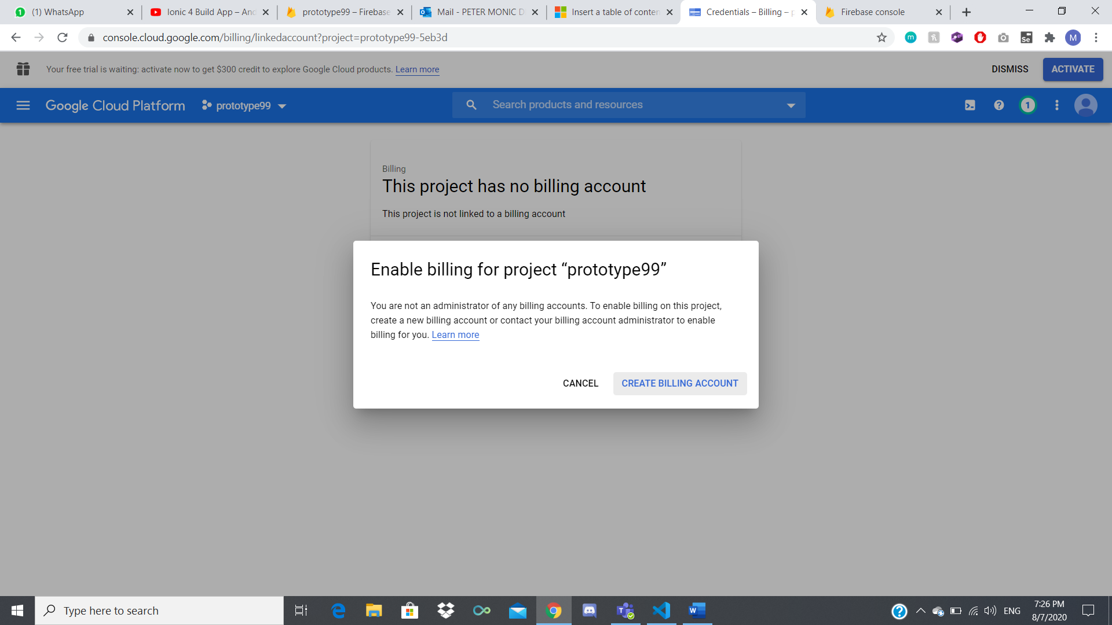

Google Maps should be successfully implemented to the project.

**Firebase Database for Google Maps – Tab 1**

Open a web browser of your choice ex. Google Chrome.

Search for Firebase Console || Click on this link: <https://firebase.google.com/>

On the top right of the page, click on “Go to console” and login with your Gmail Account.

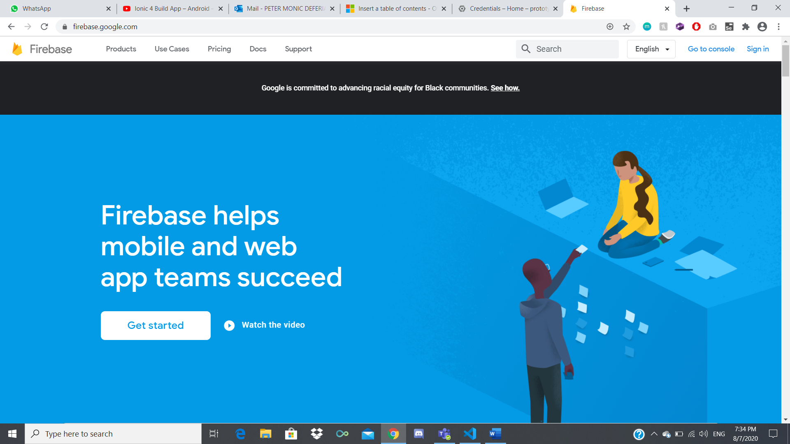

Select your Firebase Project.

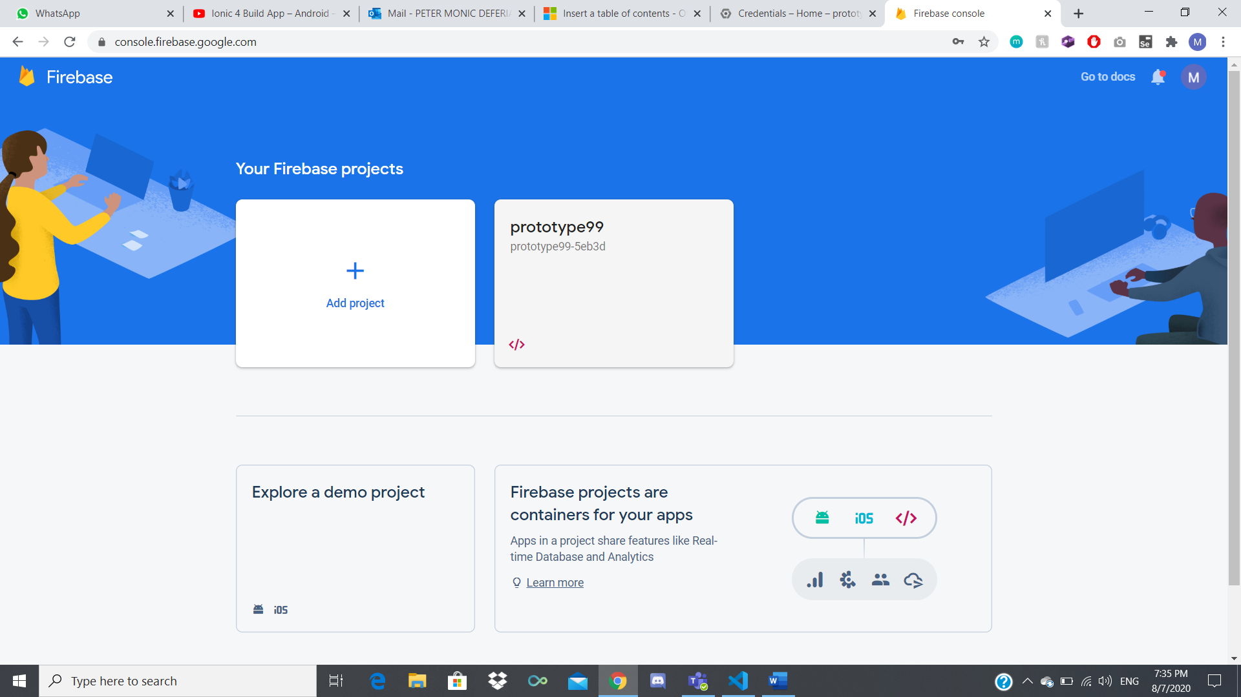

Click on “Database” > “Realtime Database”

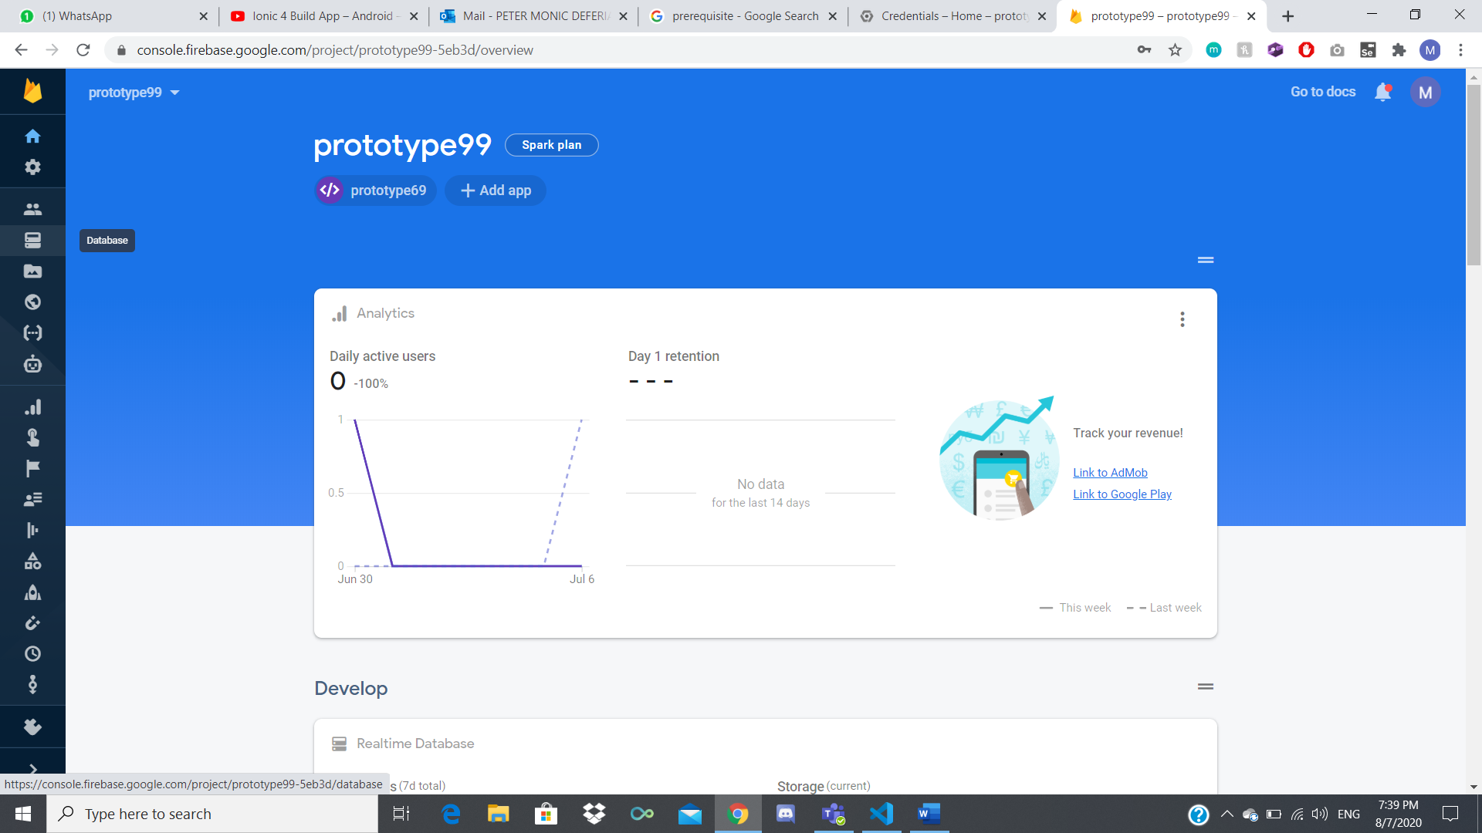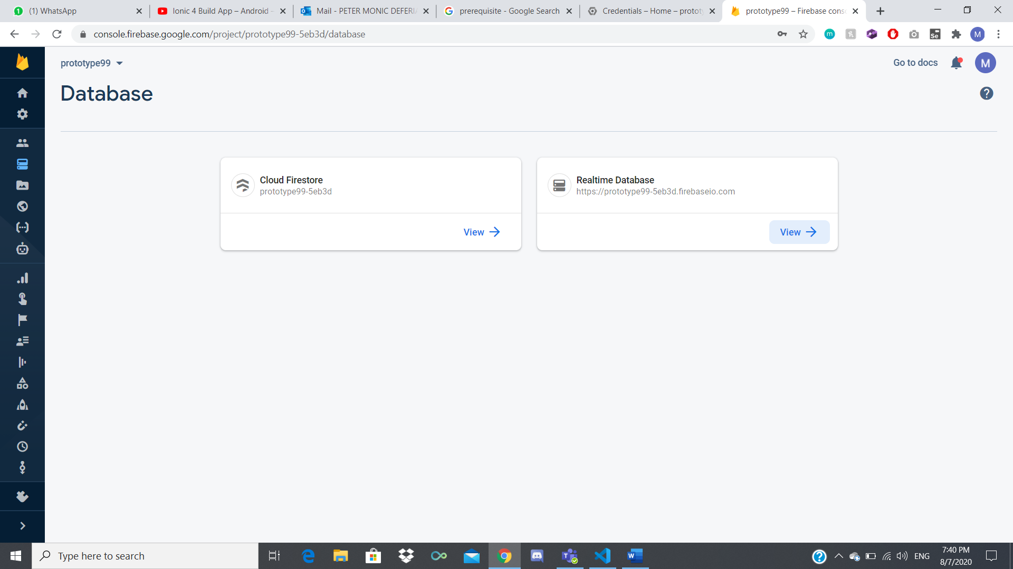

To update “AreaClusters”, “BreedingLocale”, “DengueData”, press the 3 dots and export the JSON file.

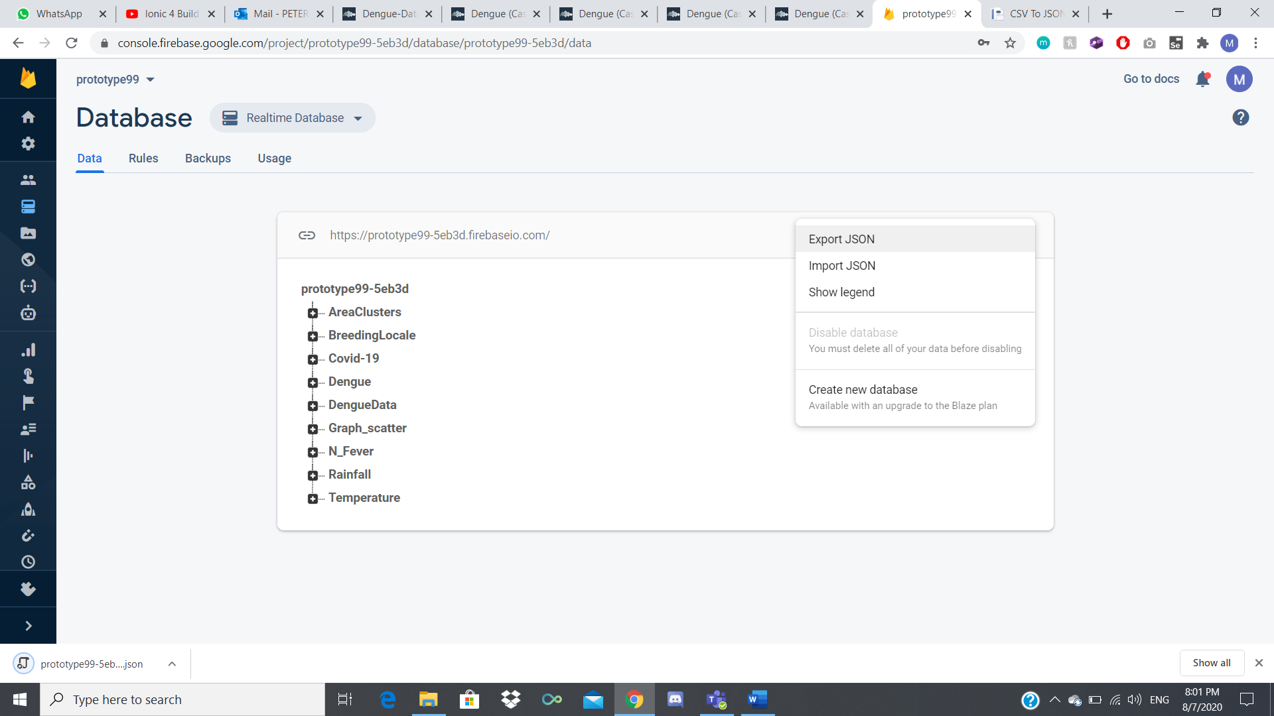

To get the latest update for “AreaClusters” download this file:

<https://data.gov.sg/dataset/dengue-cases>

Open the zip and extract the KML files

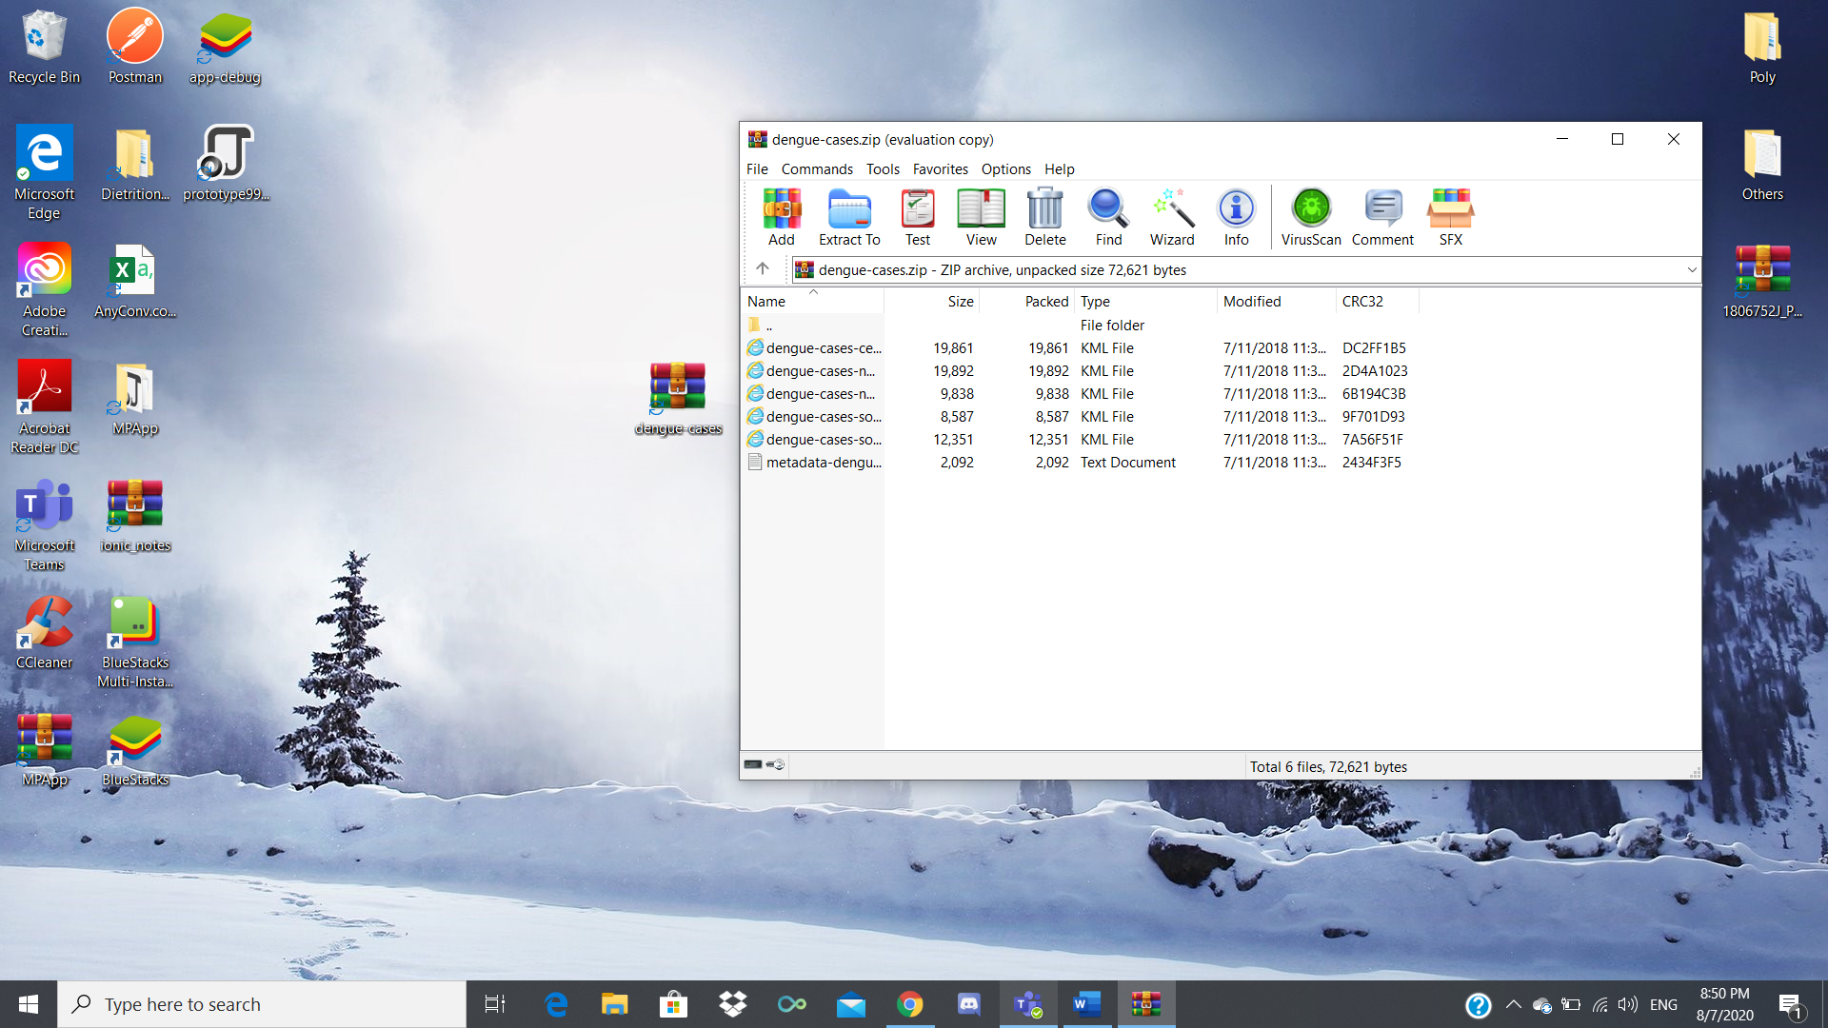

Next, we need to convert those KML files into CSV format.

Open up <https://anyconv.com/kml-to-csv-converter/> in your web browser.

Drop or Select all the files, convert and download them.

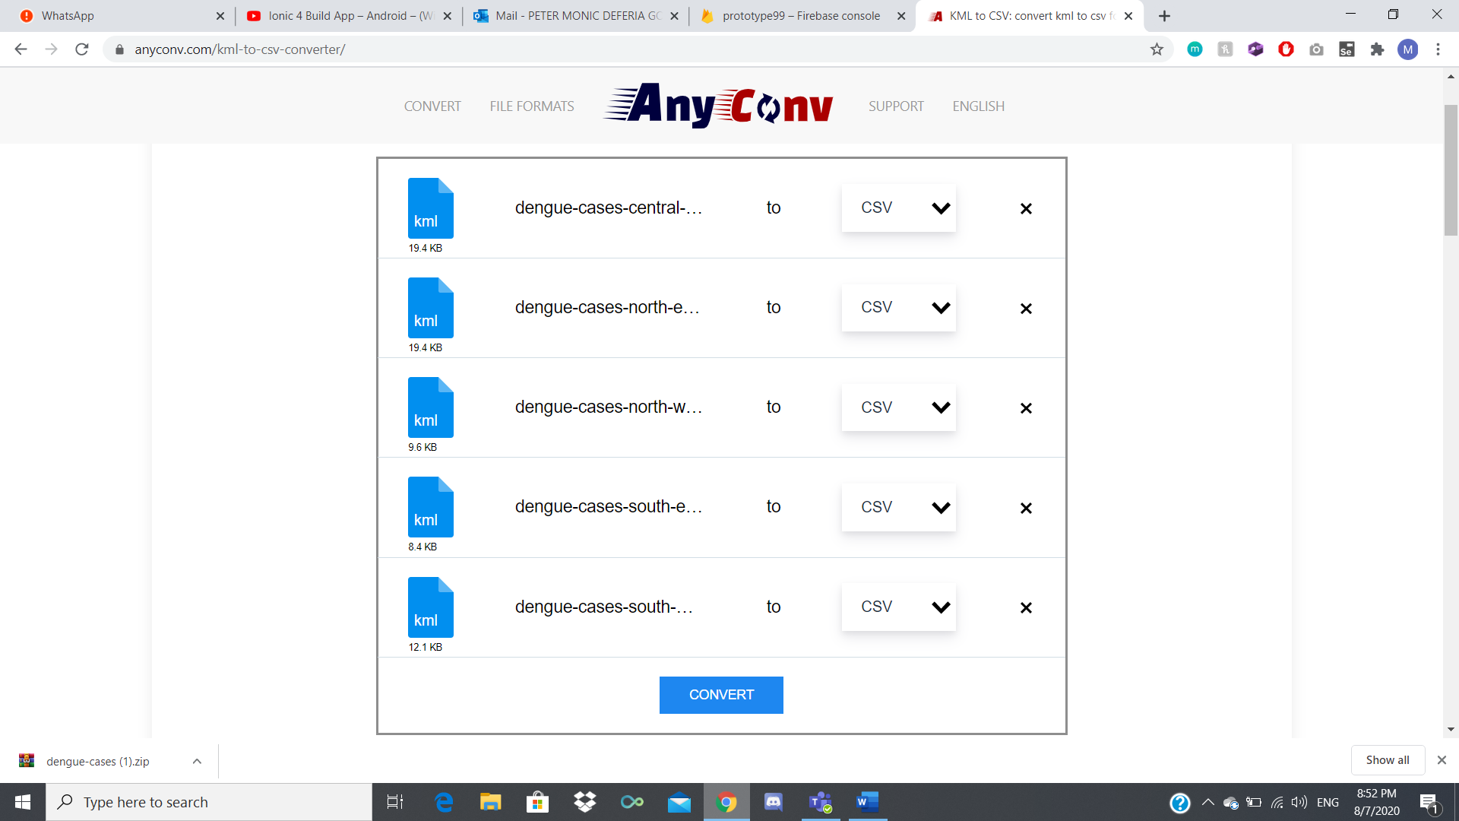 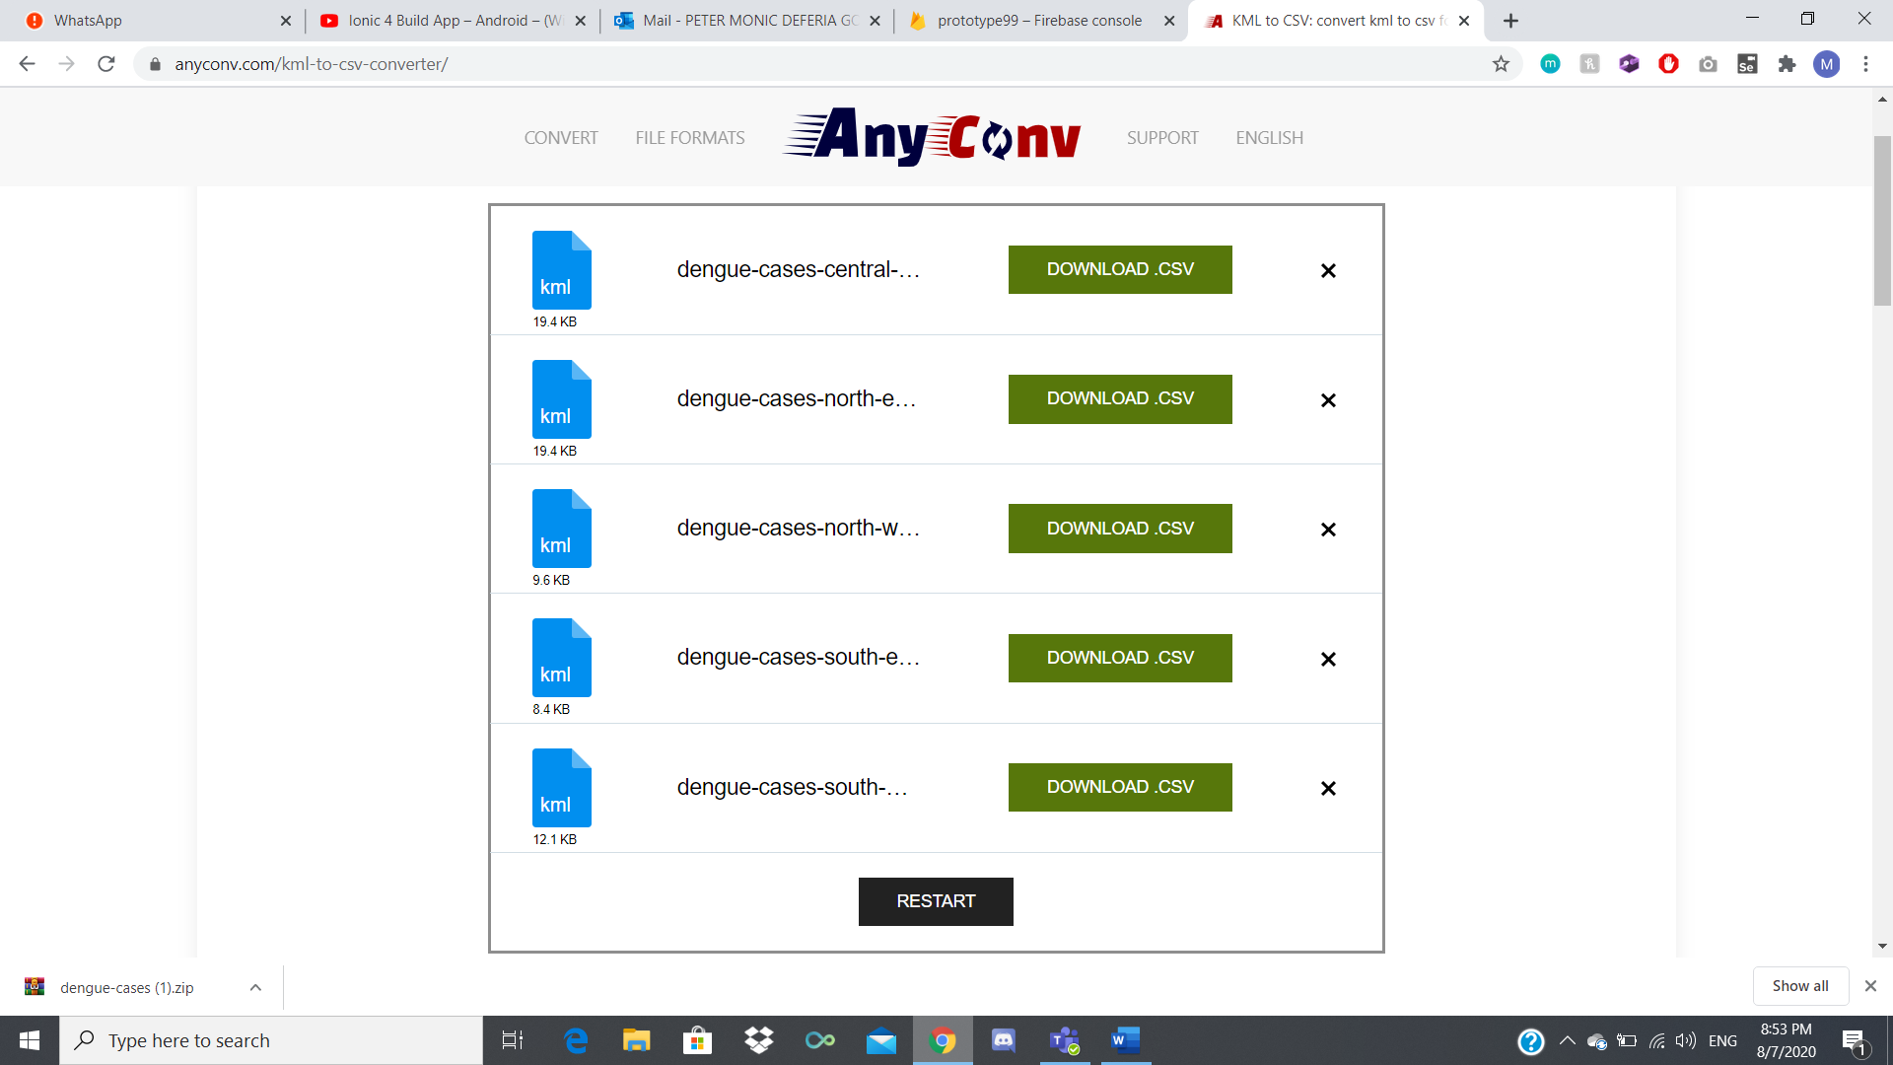

Open the Central CSV file and add fields for the area, latitude, longitude. Save it and keep it open.

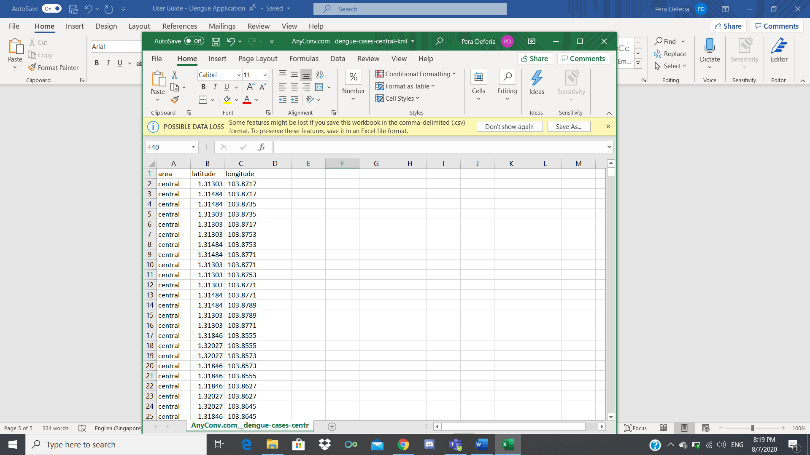

Open the other CSV files ex. north-east.

Copy the entire data, paste it in the Central CSV and fill in the area.

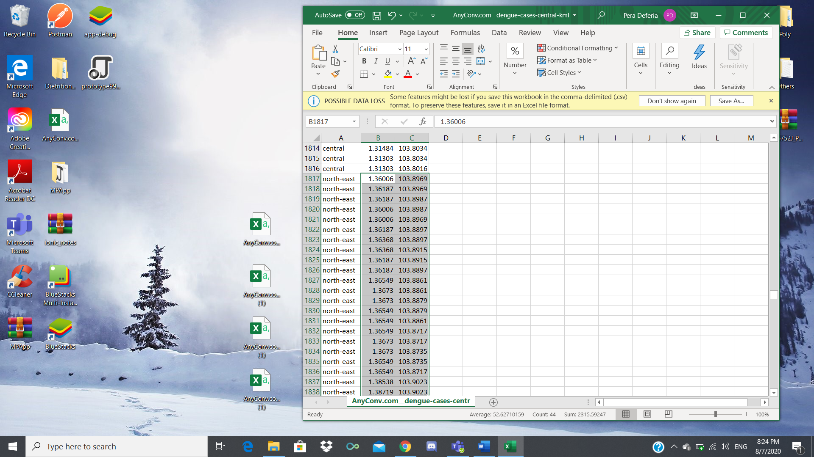

Do the same with the other CSV files and save it.

Now we need to convert the Central CSV file to JSON.

Head over to <https://www.convertcsv.com/csv-to-json.htm> and choose your Central file.

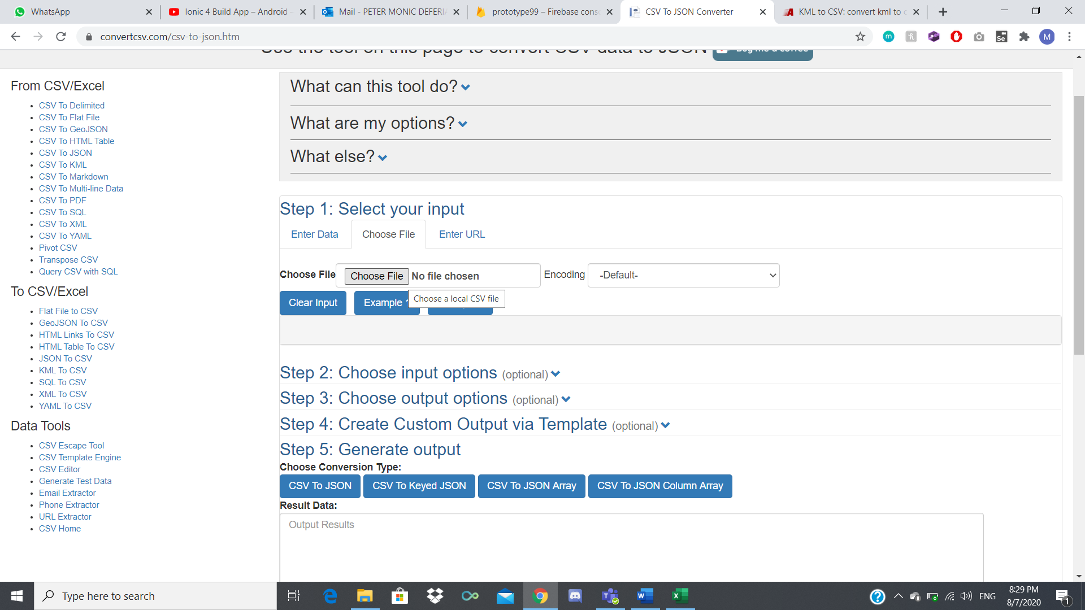

Click on “Step 3: Choose output options” and delete the 4th field position.

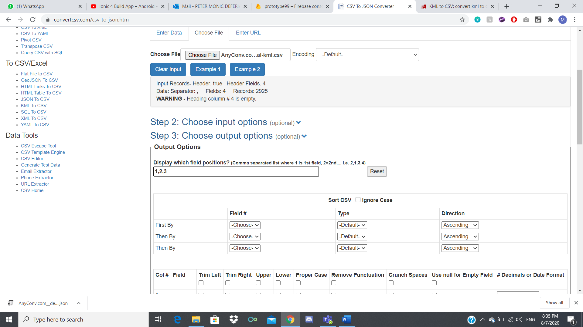

Go to Step 5, click on “CSV To JSON” to preview the changes then click “Download Result”

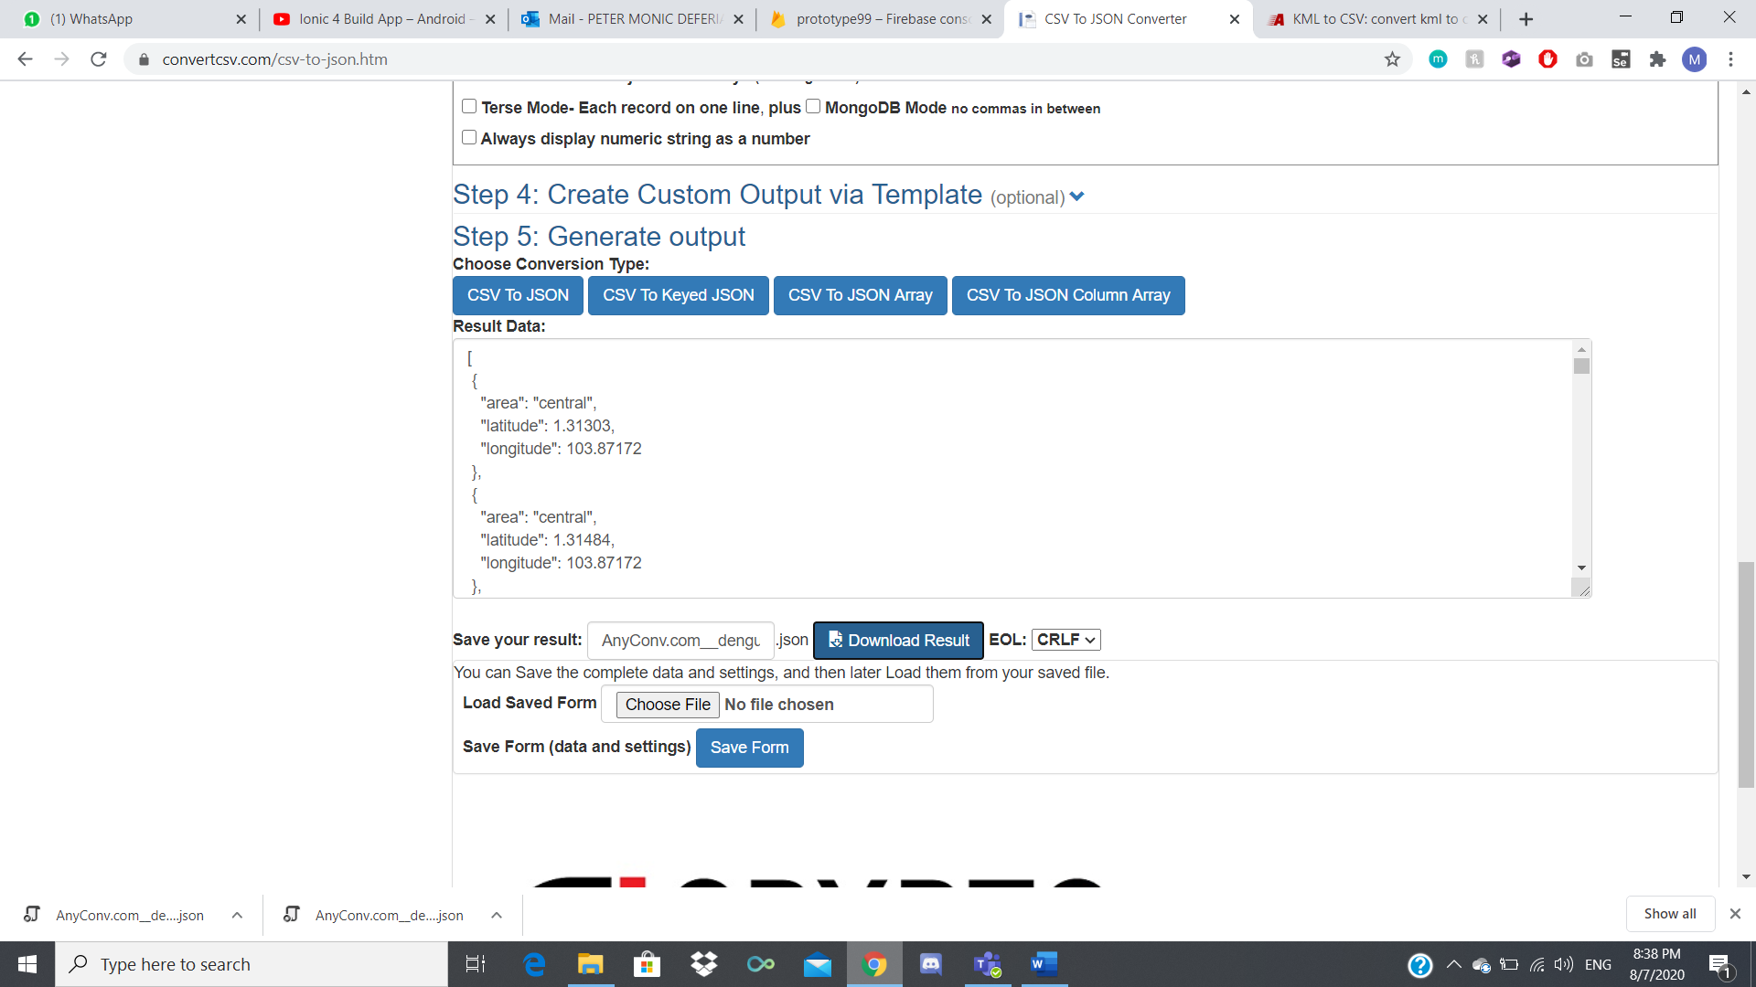

Rename the new JSON file to “AreaCluster”.

Open the exported Firebase JSON and “AreaCluster” JSON file in Visual Studio Code, create a new field called “AreaClusters” and copy the data over from “AreaCluster” JSON.

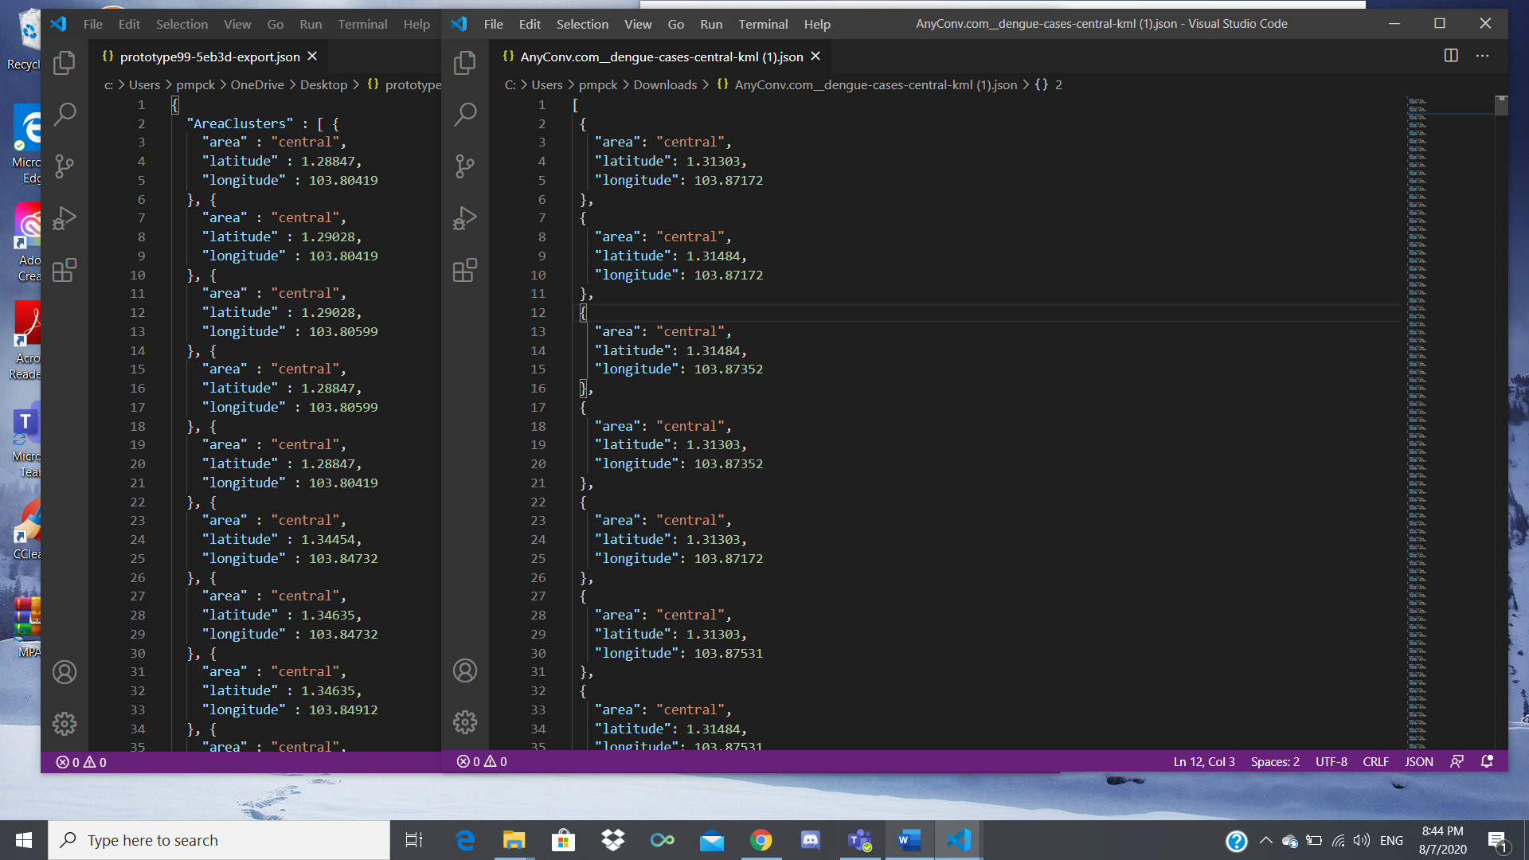

With that, our main exported dataset is updated with the latest AreaCluster dataset.

Import it into Firebase.

Here are the downloads for the “BreedingLocale” dataset:

<https://data.gov.sg/dataset/aedes-mosquito-breeding-habitats-central>

<https://data.gov.sg/dataset/aedes-mosquito-breeding-habitats-north-east>

<https://data.gov.sg/dataset/aedes-mosquito-breeding-habitats-north-west>

<https://data.gov.sg/dataset/aedes-mosquito-breeding-habitats-south-east>

<https://data.gov.sg/dataset/aedes-mosquito-breeding-habitats-south-west>

*Google Map – Tab 1 (Frontend)*

**First Visualisation – Cluster Visual**

Users can look at the frequency or clusters of dengue in the north/south/east/west regions of Singapore.

As the numbers of dengue clusters increase or decrease, the colours of the cluster would also change. Users can also click on them to separate and further look into them.

With this visualisation, you would be able to tell the frequency of dengue clusters that are occurring around Singapore.

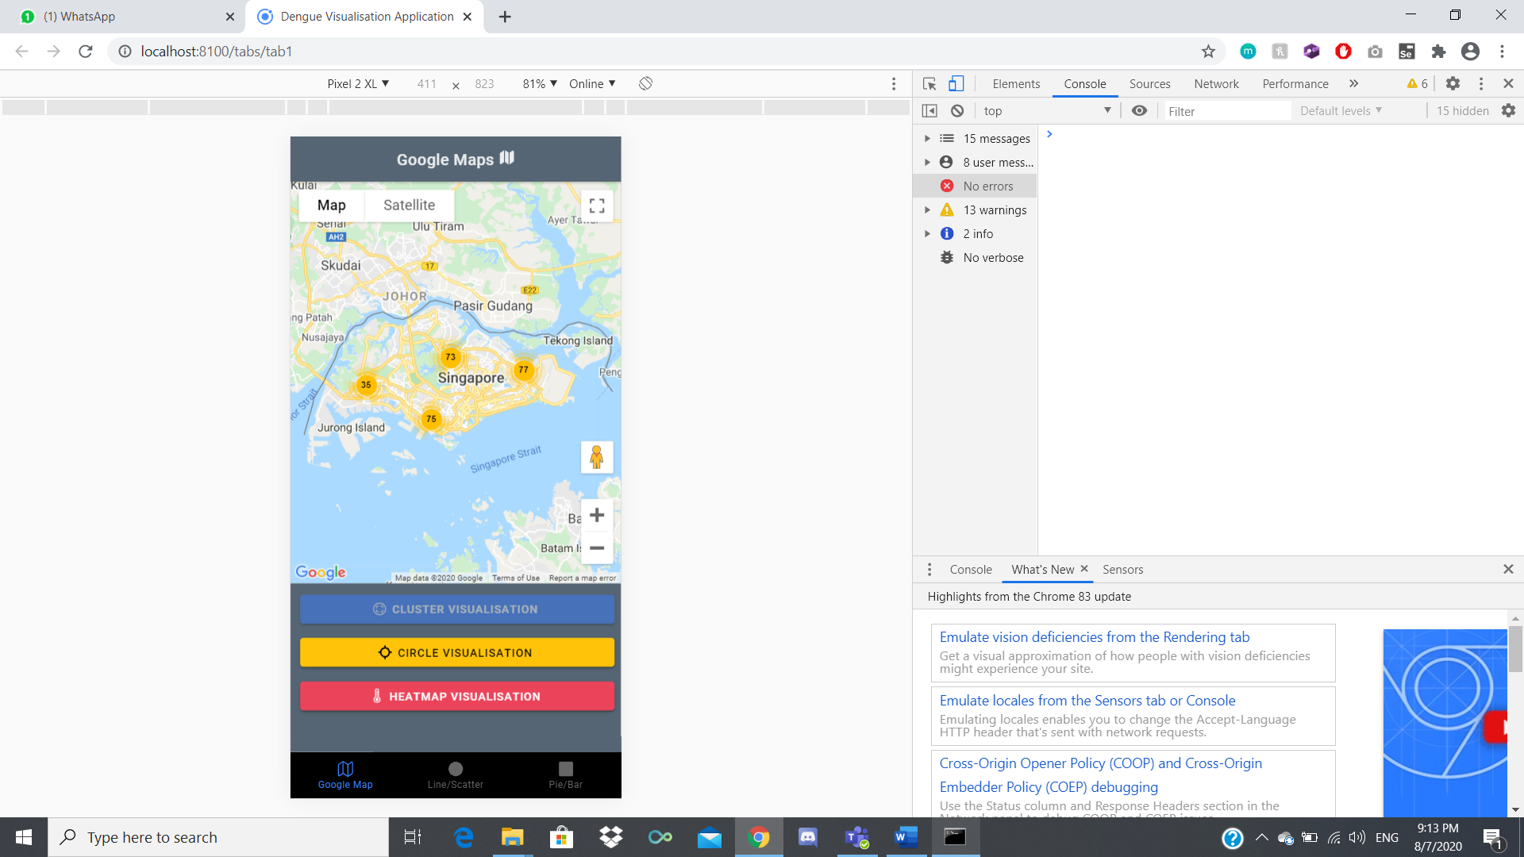 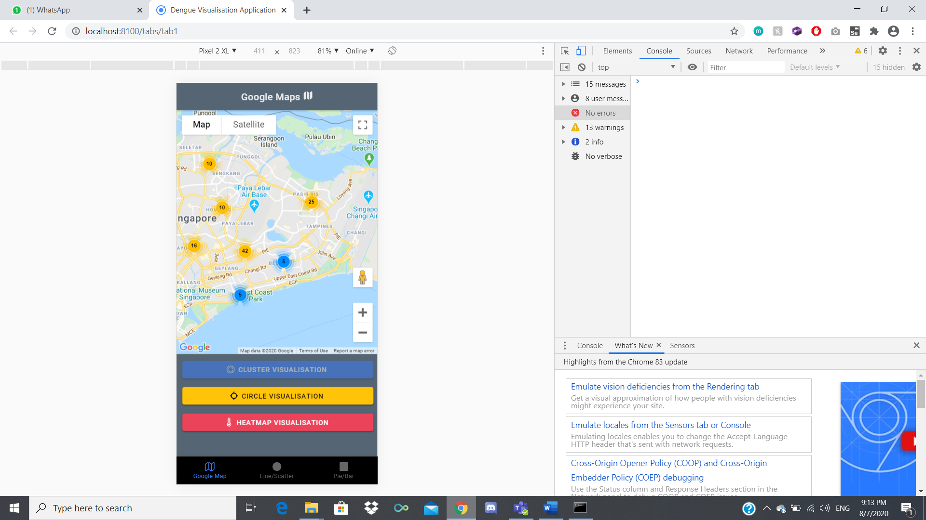

**Second Visualisation – Circle Visual**

Depending on the number of cases in an area, the colour and size of the circle will vary. If the number of dengue cases is less than 15, the circle will be small and is blue in colour. If it’s more than 15 but less than or equals to 35, the circle will be medium sized and be yellow in colour. Anything higher than 35 will have a big red coloured circle.

You can also press on the circles to have an info window pop up to display the areas affected and the number of cases within them.

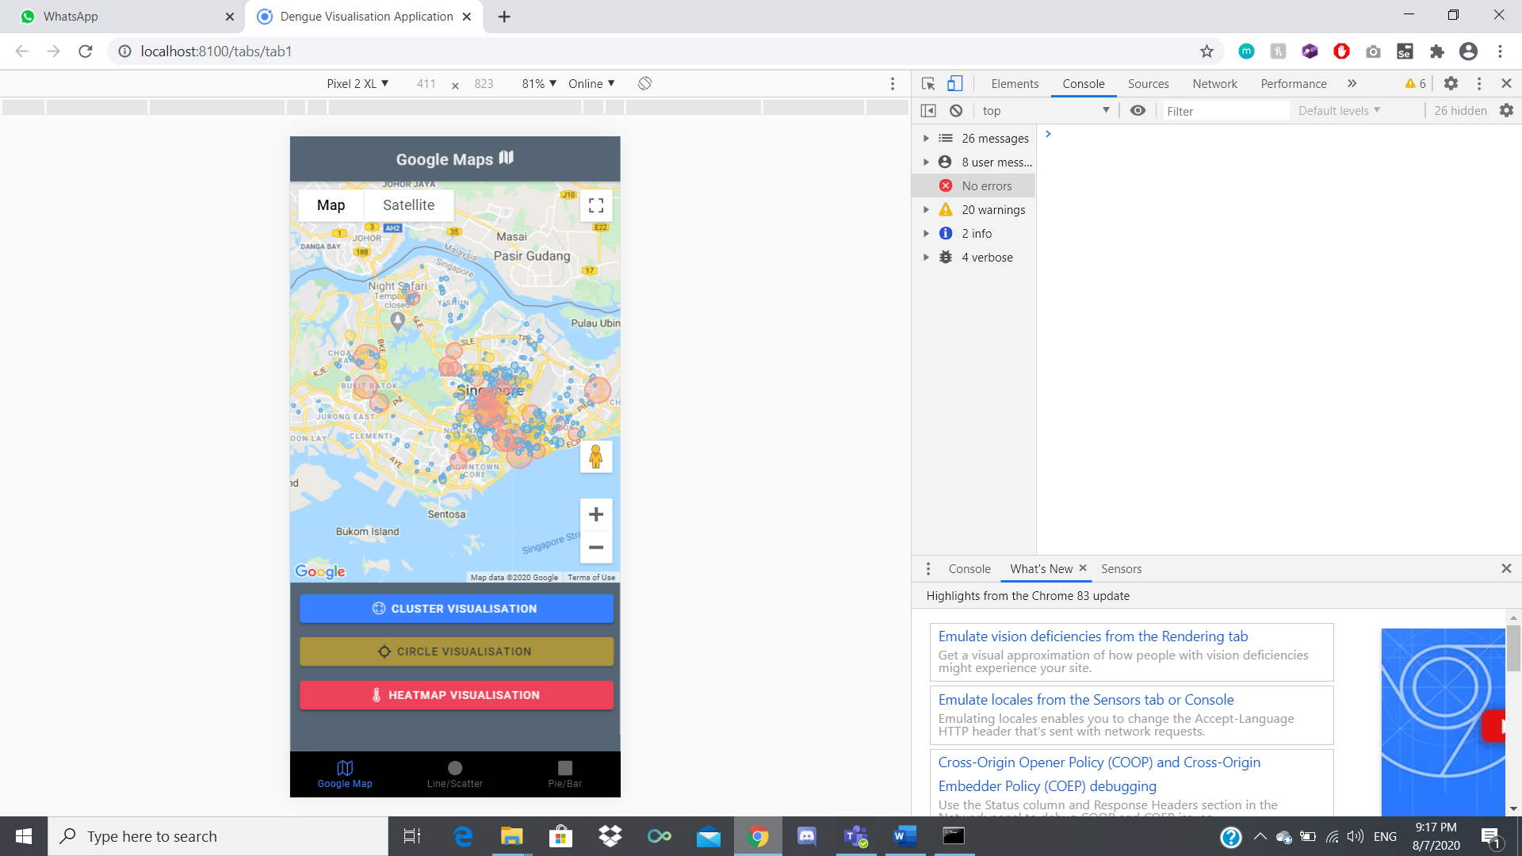 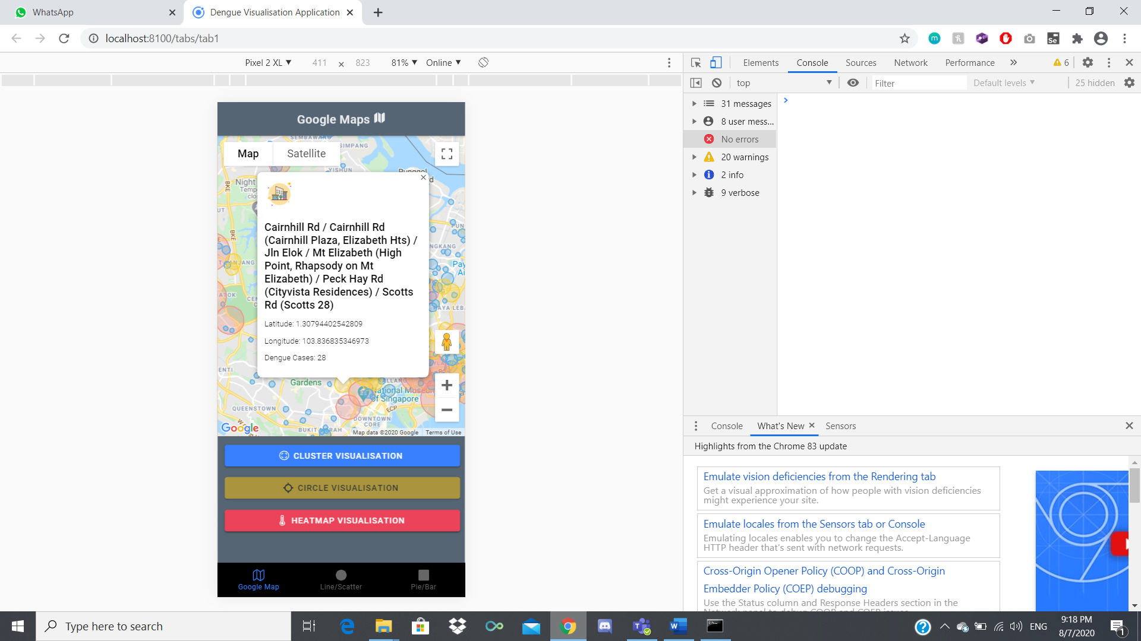

**Third Visualisation – Heatmap Visual**

After clicking on the Heatmap button, 2 ion fab buttons will appear, giving the user the ability to filter with the data shown on the map. If they are unsure what the buttons do, there are tooltips set to each button to help the user understand.

Clicking on the Gradient buttons will change the selected datasets heatmap colour to blue. Clicking on the radius buttons will change the heatmaps size and lastly clicking on the opacity will hide that specific dataset.

Using this, users will be able to see the correlation between the Mosquito Breeding Hotspots and the spread of the Number of Dengue Cases throughout Singapore.

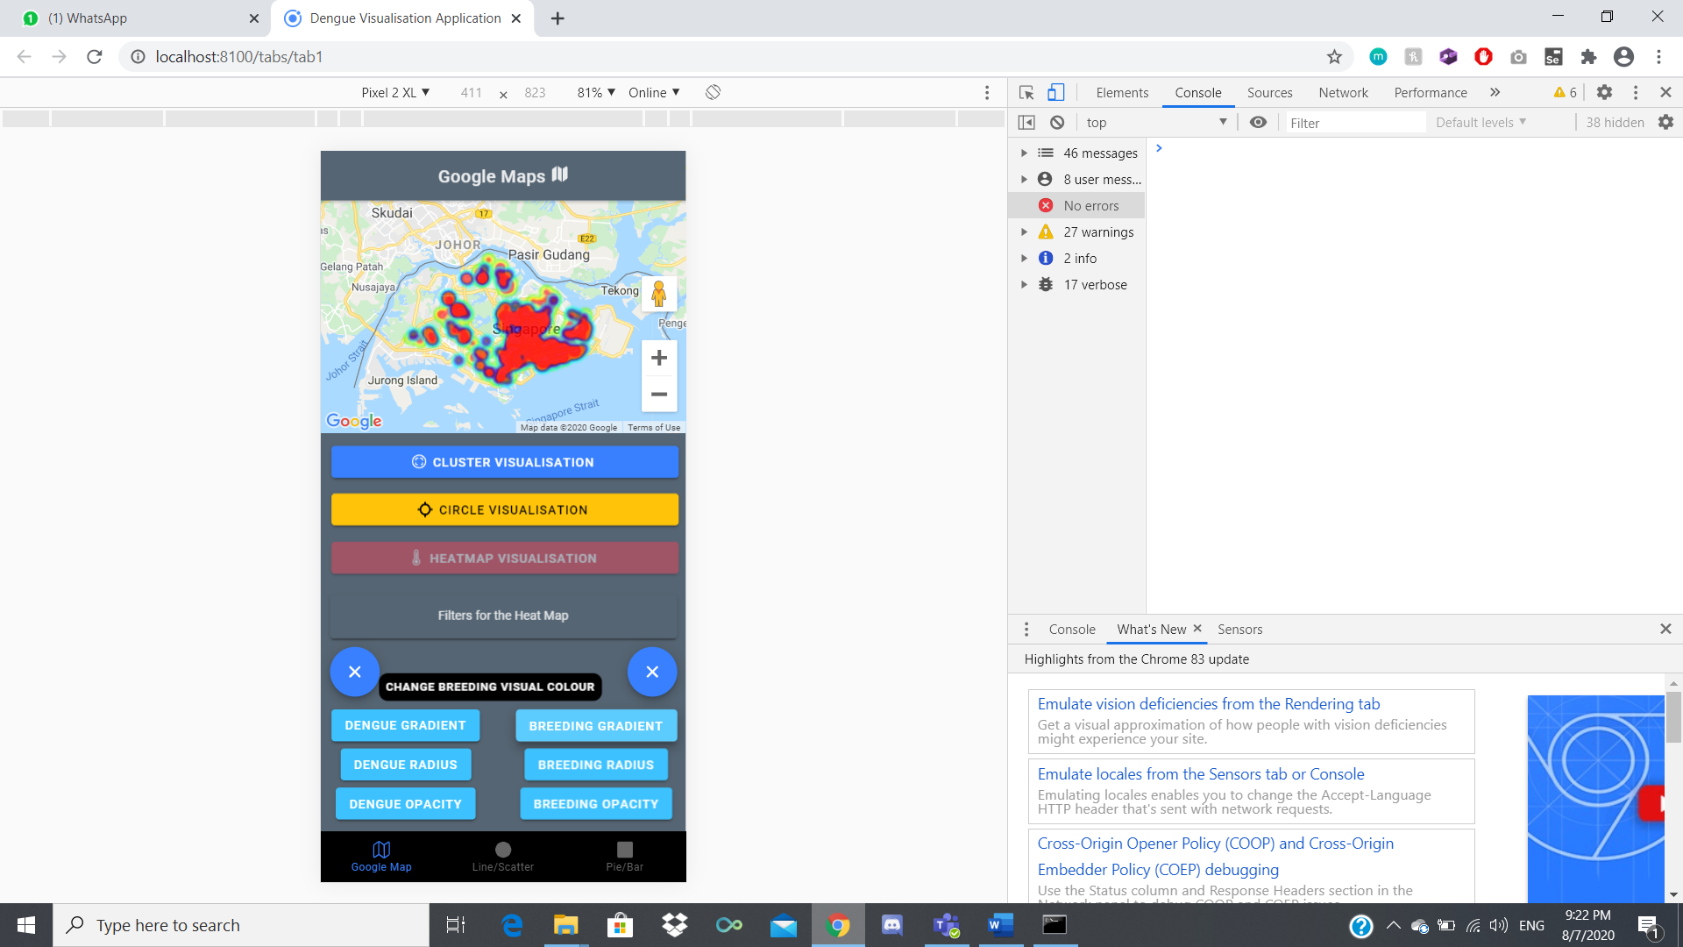 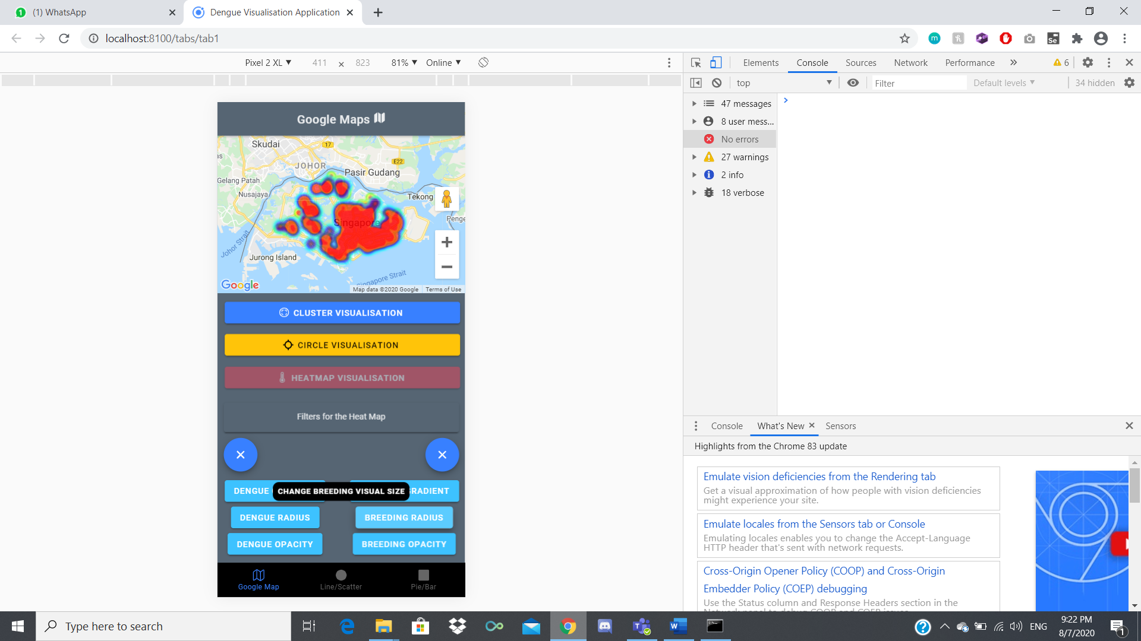 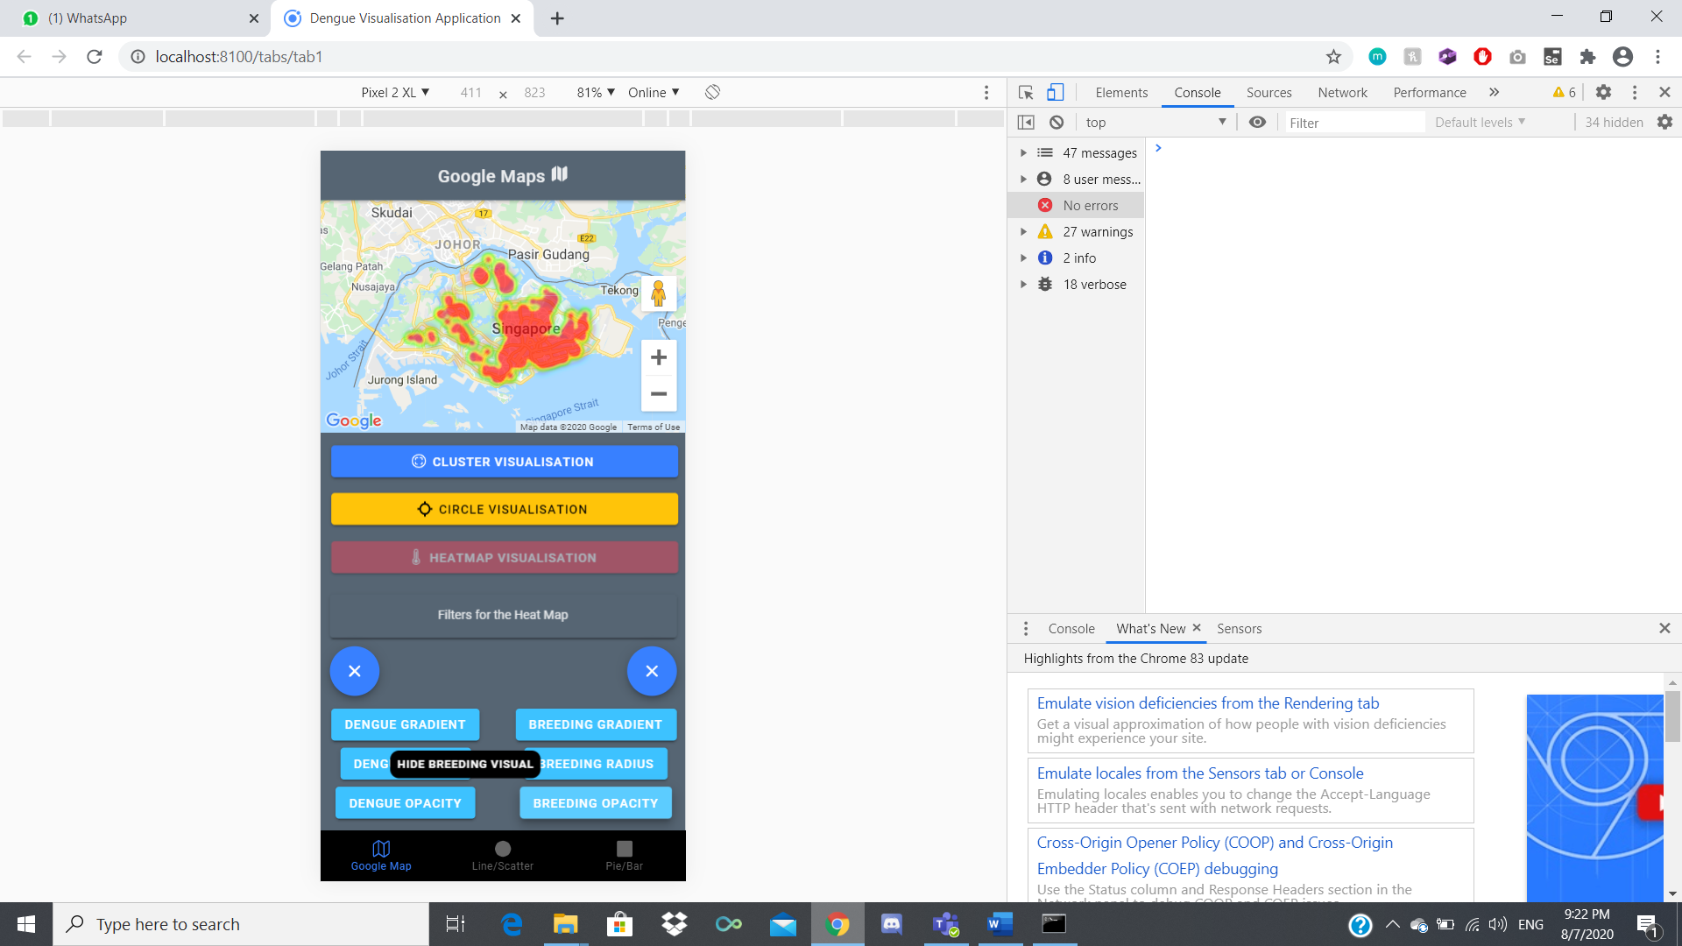

*Line/Scatter Data visualisation– Tab 2 (Backend)*

Open a web browser of your choice ex. Google Chrome.

Search for Firebase Console || Click on this link: <https://firebase.google.com/>

On the top right of the page, click on “Go to console” and login with your Gmail Account.



Select /Create your Firebase Project.



Click on “Database” > “Realtime Database”



Import the JSON file provided in the document

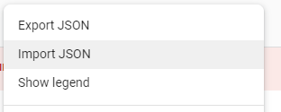

Hover over the “Graph_scatter section and press the plus button for the datasets used in tab 2.

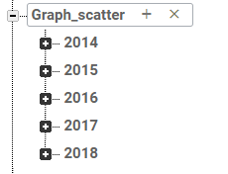

The dataset used in this section:

* PSI dataset

<https://data.gov.sg/dataset/historical-24-hr-psi>

* Rainfall dataset

<https://data.gov.sg/dataset/rainfall-monthly-total>

* Temperature dataset

<https://data.gov.sg/dataset/surface-air-temperature-monthly-mean>

* WeatherOnline

<https://www.weatheronline.co.uk/weather/maps/city?FMM=1&FYY=2000&LMM=4&LYY=2020&WMO=48698&CONT=asie&REGION=0027&LAND=SX&ART=WDR&R=0&NOREGION=0&LEVEL=162&LANG=en&MOD=tab>

*Line/Scatter Data visualisation– Tab 2 (Front-end)*

This section provides users with the ability to visualized the datasets in forms of line graph and scatter plot, users can zoom in the graph as shown.

Unzoomed Zoomed

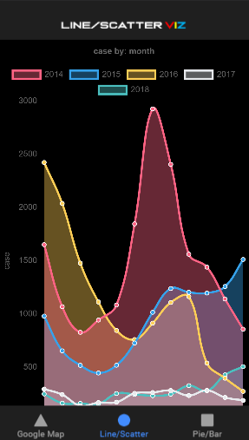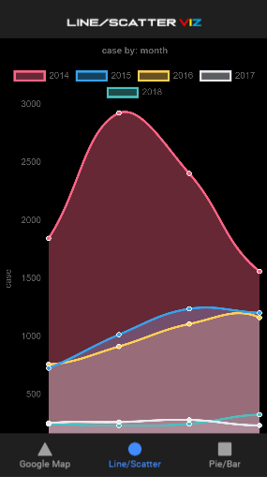

It also offers comparison popup screen for users to visualized better when user hover/press the point they are interested in viewing on the graph.

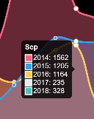

The legend sections can also be pressed to turn on/off to filter the year user want to visualize. (In this case year 2014 is pressed so it is turned off as shown)

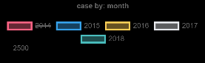

Graph section with year 2014 filtered out

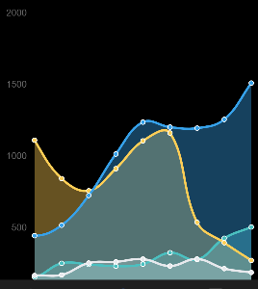

When scrolled down further,users can also see the setting section where they can play around with the settings in scatter plot forms or line graph form. The line graph and scatter plot will change depending on the settings the user choose to visualise.

Non-active accordion Active accordion

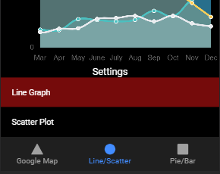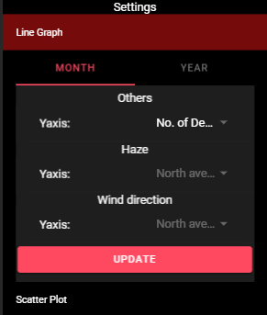

In-order to play with the settings users must select the dropdown section they are interested in and press the update button to make changes.

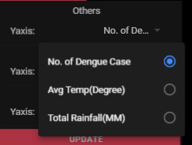

Example of the scatter plot ( Yaxis: Rainfall and Xaxis: dengue case)

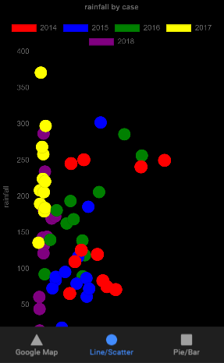

Example of active scatterplot accordion

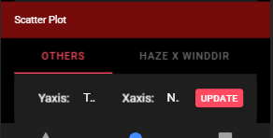

**Firebase Database for Bar Graph / Pie Chart Visualisation– Tab 3**

Open a web browser of your choice ex. Google Chrome.

Search for Firebase Console || Click on this link: <https://firebase.google.com/>

On the top right of the page, click on “Go to console” and login with your Gmail Account.



Select your Firebase Project.



Click on “Database” > “Realtime Database”



Step 1: click on beside your database name there will be a plus sign

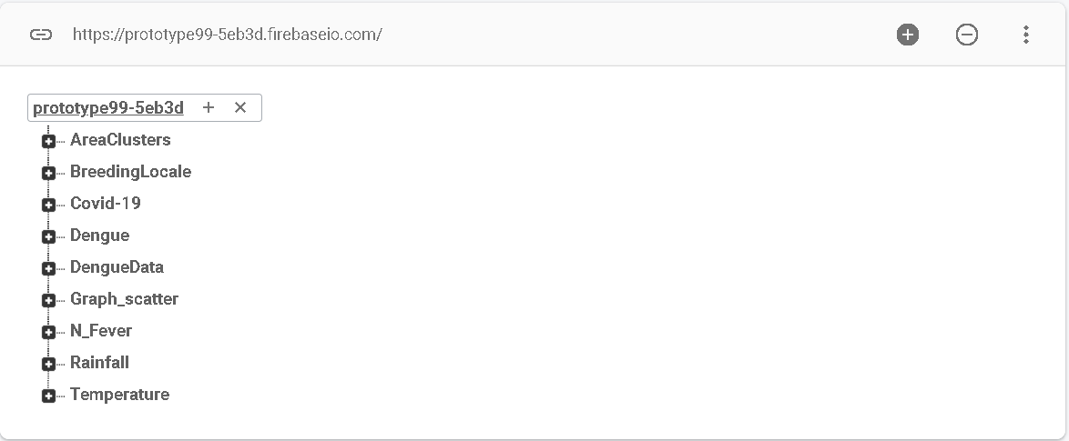

Step 2: Type in the name of the column you want and click on the plus sign

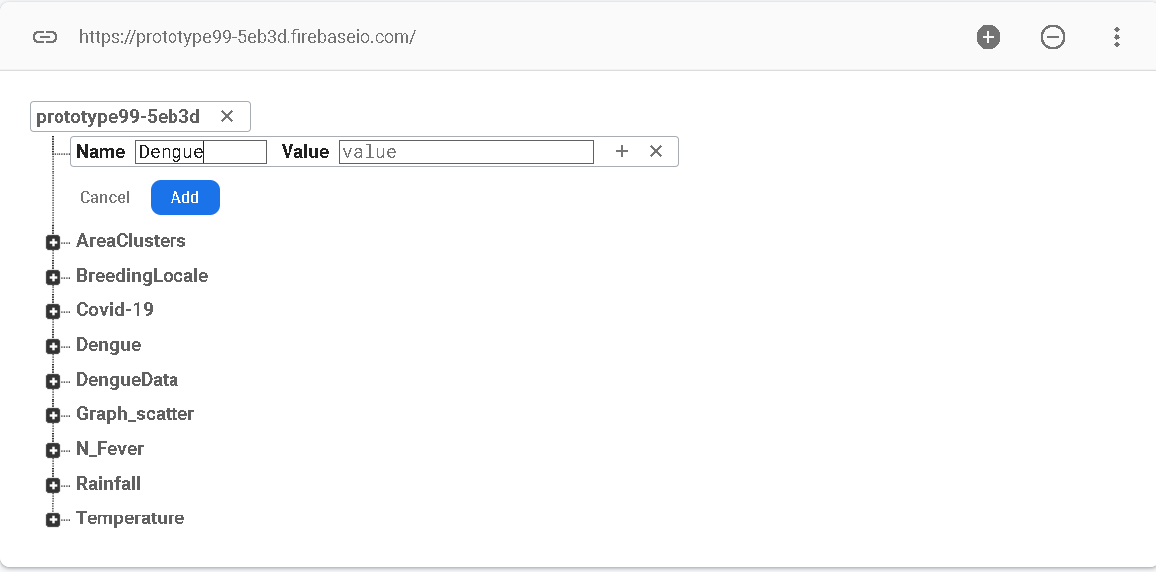

Step 3: Type in the year you want and click on the plus sign

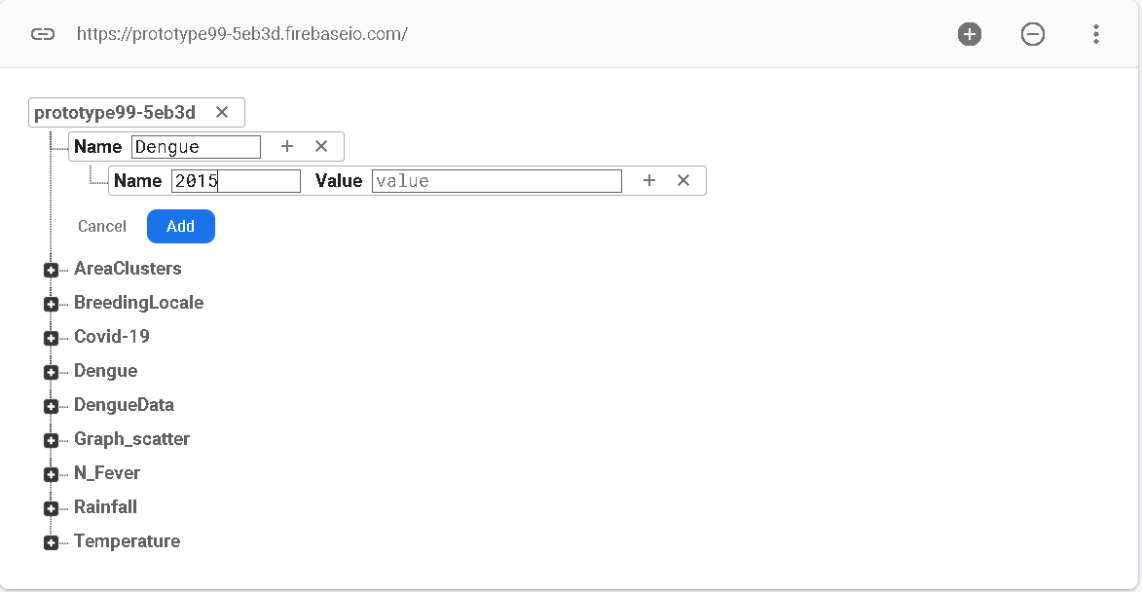

Step 4: Type in the number of the data so firebase starts from 0

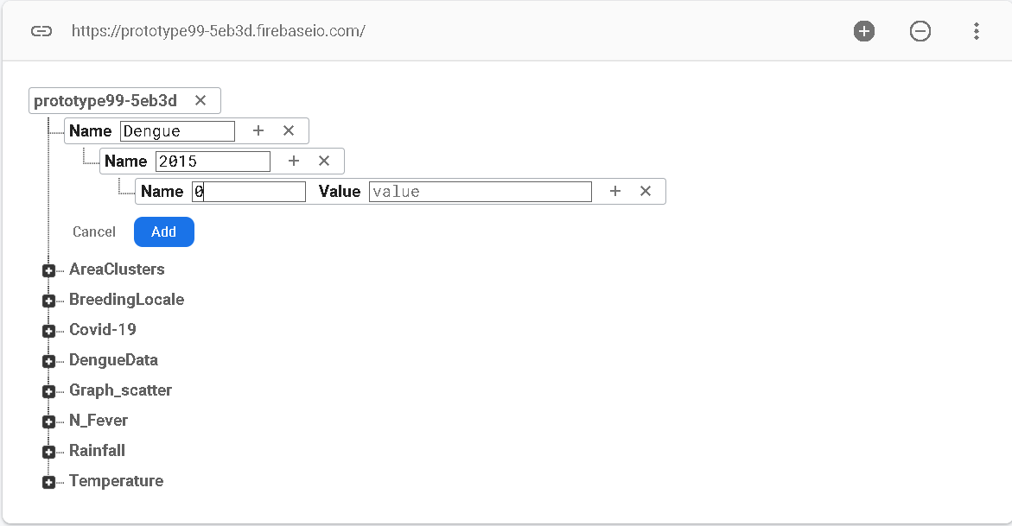

Step 5: write the data after getting the data from the government (note : for numbers do remember to string them “201” because the codes will be reading in string format, you can covert these data to integer later on in the backend)

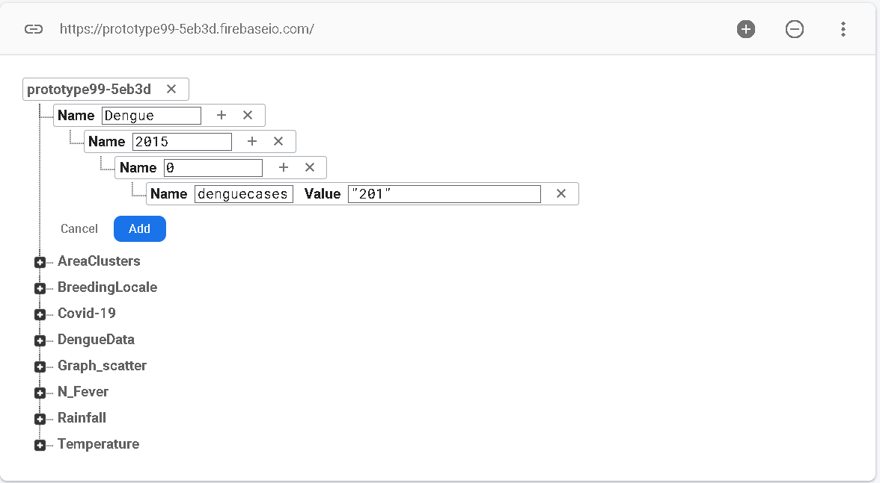

Step 6: if you want to add more data press tab and click add

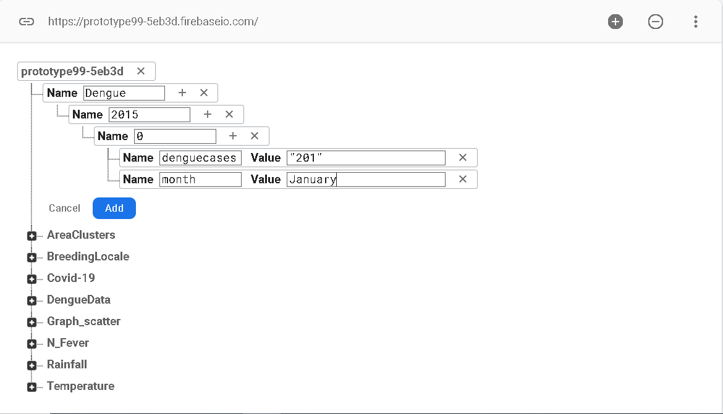

Step 7: if you want to add more data into the year click on the + button near the year

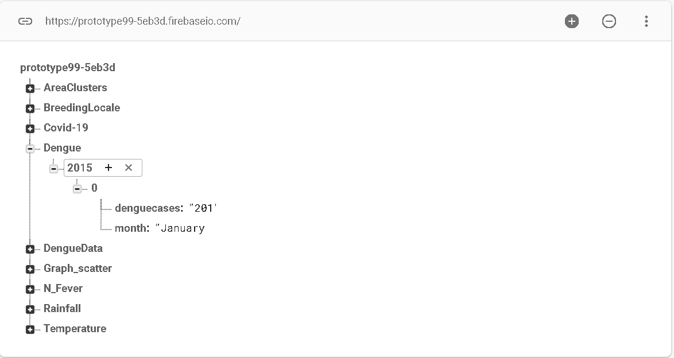

Repeat from step 7 to add all the data in

It is the same for temperature data and rainfall data

The reason why i type in manually is because i adjusted the data such as dengue data is given to us by weeks i just compile it and made them into months to organise the data.

Here are the links for the 3 datasets

Dengue: <https://data.gov.sg/dataset/weekly-number-of-dengue-and-dengue-haemorrhagic-fever-cases>

Rainfall: <https://data.gov.sg/dataset/rainfall-monthly-total>

Temperature:<https://data.gov.sg/dataset/surface-air-temperature-monthly-mean>

*Pie/Bar– Tab 3 (Frontend)*

**First Visualisation – Bar graph**

So, for the first visualisation for the bar graph will be able to view the year selected by the user. They can view the data of all three combined side by side

Users can tell the temperature/ the dengue cases and the rainfall each month

All they have to do is to select the year and click submit.

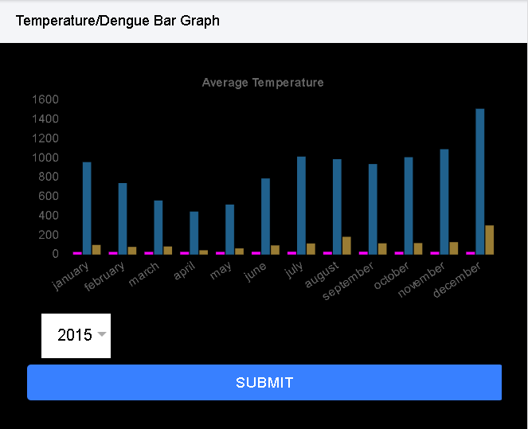

**First Visualisation – Bar graph**

For the second pie chart visualisation they can see the number of dengue cases more clearly every month

All they have to do is to select the year and click submit.

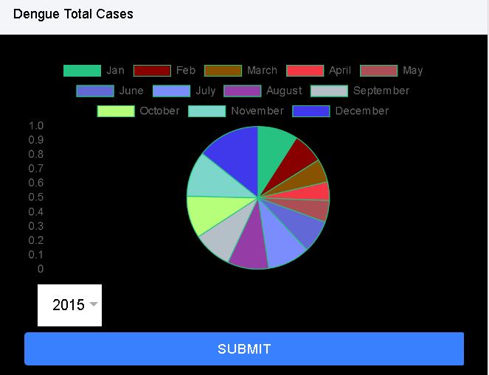

*Testing the Application*

Requirements:

* Java JDK 8

<https://www.oracle.com/sg/java/technologies/javase/javase-jdk8-downloads.html>

* Set up the Environmental Variables
* APK
* Visual Studio Code / Other emulators (ex. BlueStack)

Optional:

* Connected Android Phone
  + Phone is in Developer mode
  + Enabled USB debugging

**Setting up Environmental Variables**

Go into Control Panel > System and Security > System > Advanced system settings.

The system properties will pop up.

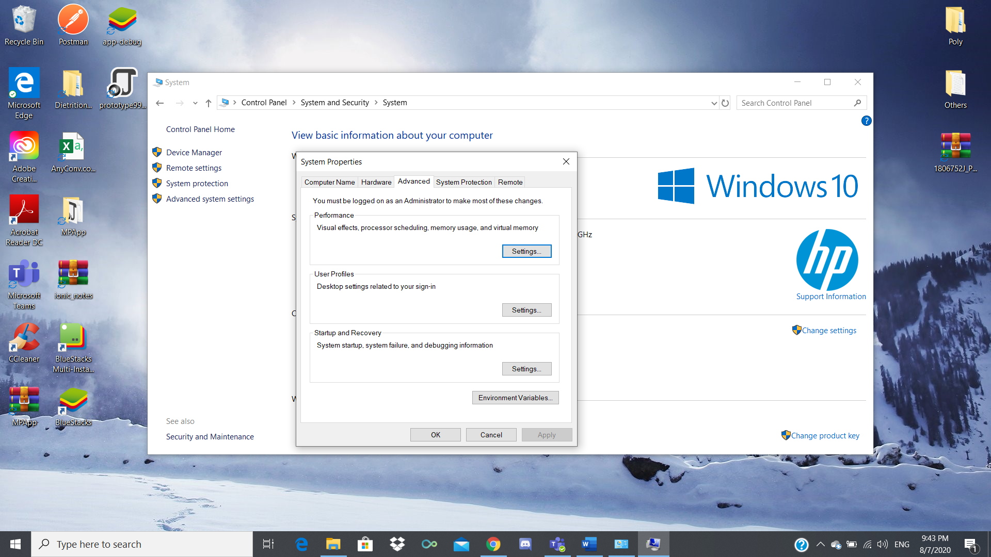

Click on Environmental Variables. Under User variables, click “New…” and fill this in:

Variable name: ANDROID_HOME

Variable value: (Your Android SDK path)

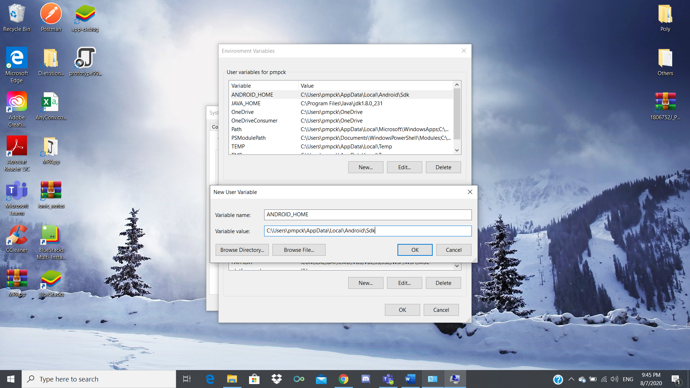

Click “OK”. Again, under User variables, click “New…” and fill this in:

Variable name: JAVA_HOME

Variable value: (Your Java JDK 1.8^ path)

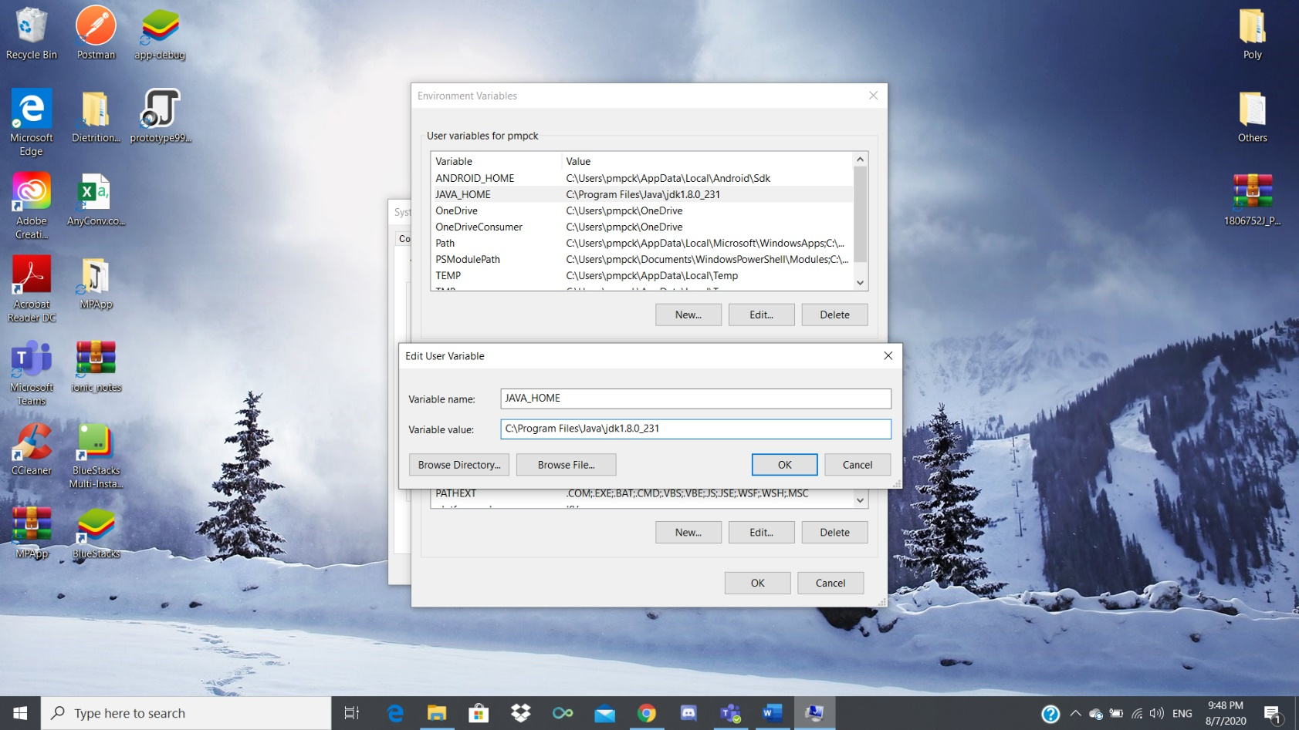

Click “OK”. Under System variables, select the “Path” variable and click “Edit...”

Locate and copy the path for your platform-tools, tools under Android\SDK.

Click “New” and add them in one by one.

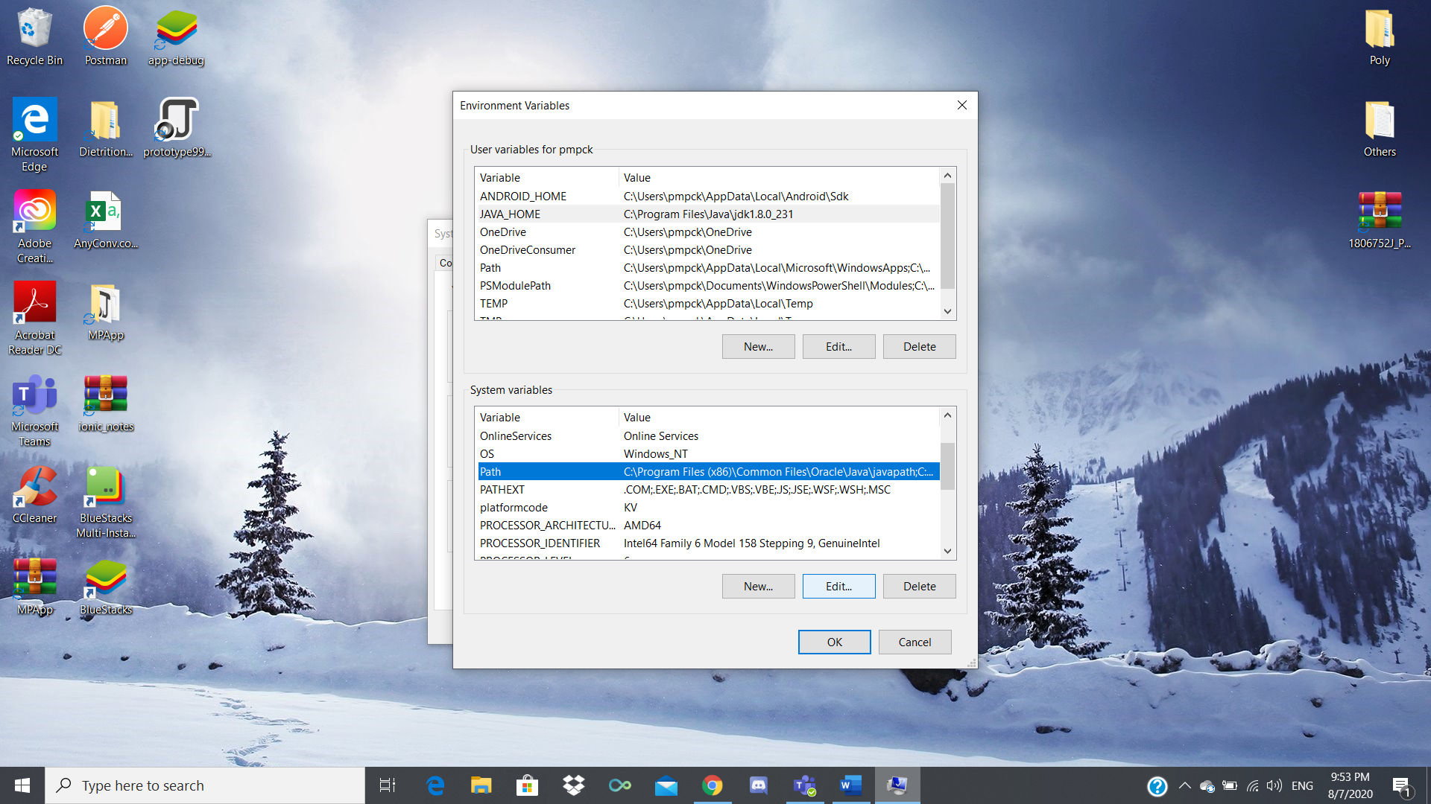 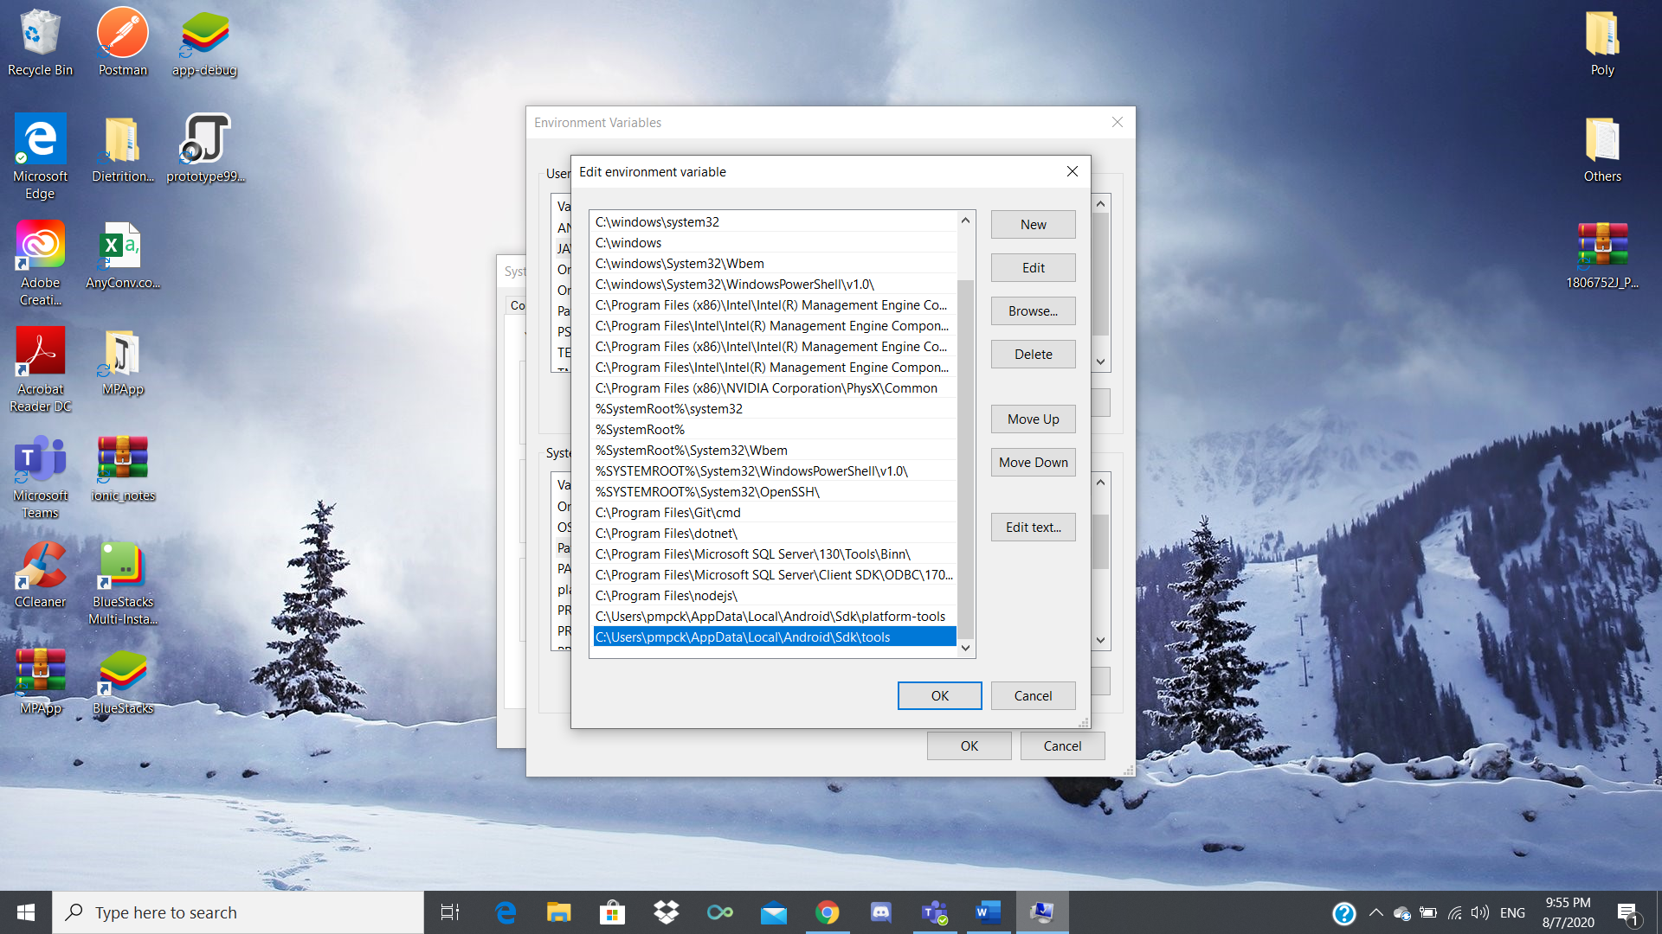

**Running it in Visual Studio Code**

Open “MPApp” in Visual Studio Code.

Start a new Terminal.

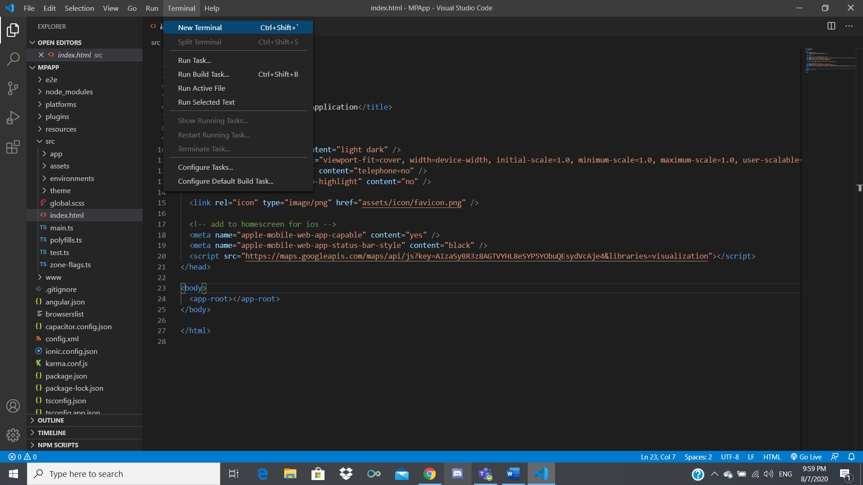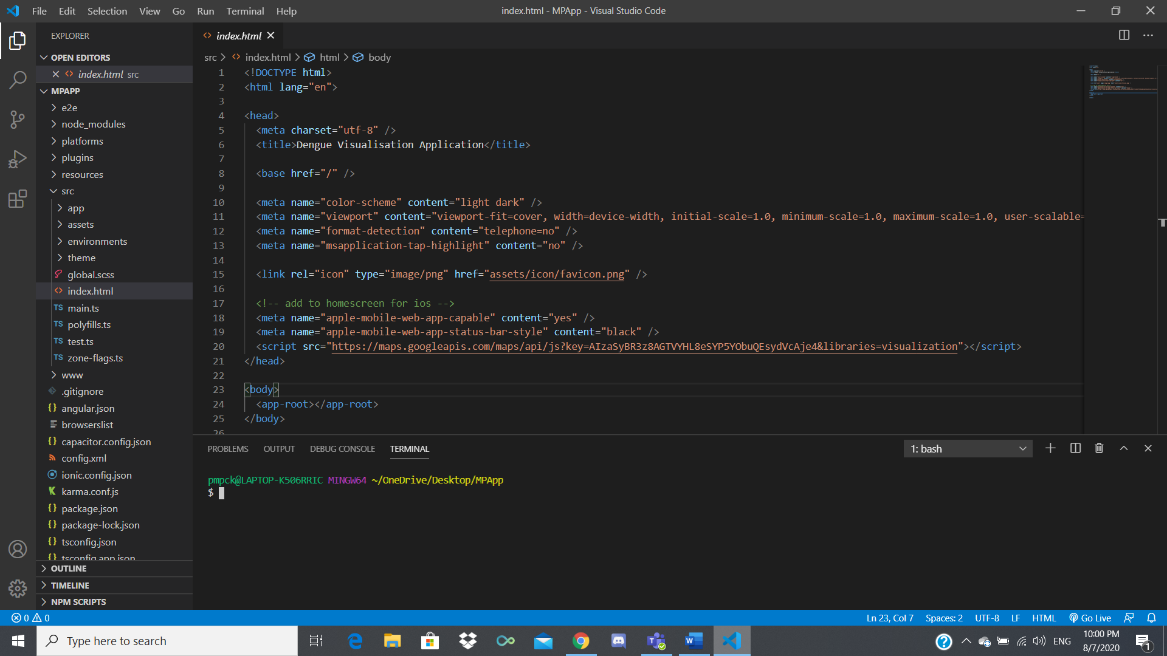

Type in “ionic cordova run android” in the Terminal and hit enter.

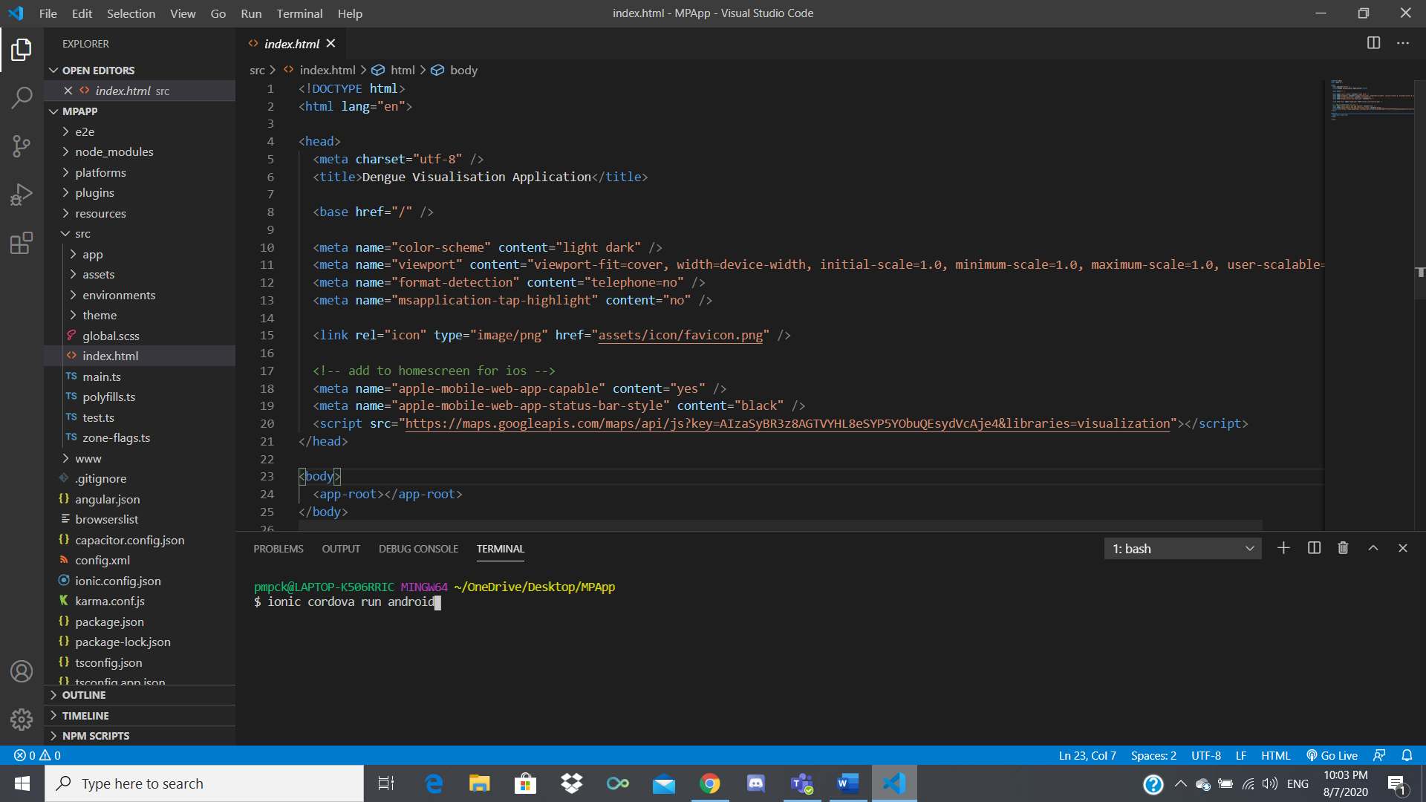

If you have an Android phone connected (Developer mode and USB debugging enabled), a pop up will appear on your phone asking for a connection, accept it.

The application will then run on your phone (Might have to redo it since you just accepted the connection)

If no phones are connected, the application will run on an emulator instead, as shown below.

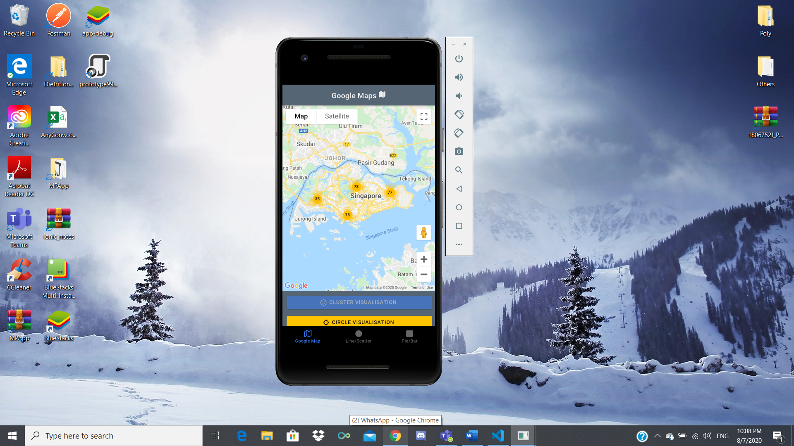

You can just close the emulator after testing.

**APK**

To find the APK go to:

(Where you saved the application folder) \ MPApp \ platforms \ android \ app \ build \ outputs \ apk \ debug

An Example:

C:\Users\pmpck\OneDrive\Desktop\MPApp\platforms\android\app\build\outputs\apk\debug